The default route in Internet Protocol Version 4 (IPv4) is designated as the zero-address 0.0.0.0/0 in CIDR notation, often called the quad-zero route. The subnet mask is given as /0, which effectively specifies all networks, and is the shortest match possible.

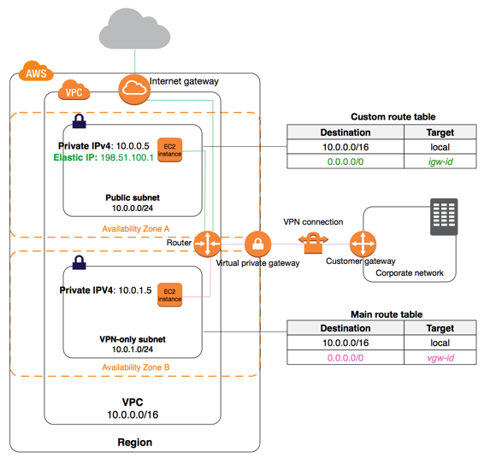

You can use a NAT device to enable instances in a private subnet to connect to the Internet (for example, for software updates) or other AWS services, but prevent the Internet from initiating connections with the instances. A NAT device forwards traffic from the instances in the private subnet to the Internet or other AWS services, and then sends the response back to the instances. When traffic goes to the Internet, the source IPv4 address is replaced with the NAT device’s address and similarly, when the response traffic goes to those instances, the NAT device translates the address back to those instances’ private IPv4 addresses.

NAT devices are not supported for IPv6 traffic—use an egress-only Internet gateway instead.

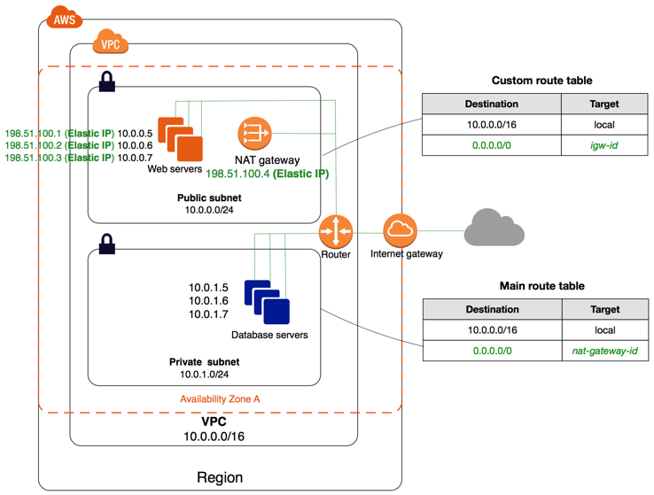

A virtual private gateway is the VPN concentrator on the Amazon side of the VPN connection. You create a virtual private gateway and attach it to the VPC from which you want to create the VPN connection.

When you create a virtual private gateway, you can specify the private Autonomous System Number (ASN) for the Amazon side of the gateway. If you don't specify an ASN, the virtual private gateway is created with the default ASN (64512). You cannot change the ASN after you've created the virtual private gateway.

**Static Amazon EBS vs. Auto-Scaled Amazon EFS**

## Inexpensive Amazon S3 vs. High-performance Amazon EFS

Each EC2 instance performs source/destination checks by default. This means that the instance must be the source or destination of any traffic it sends or receives. However, a NAT instance must be able to send and receive traffic when the source or destination is not itself. Therefore, you must disable source/destination checks on the NAT instance.

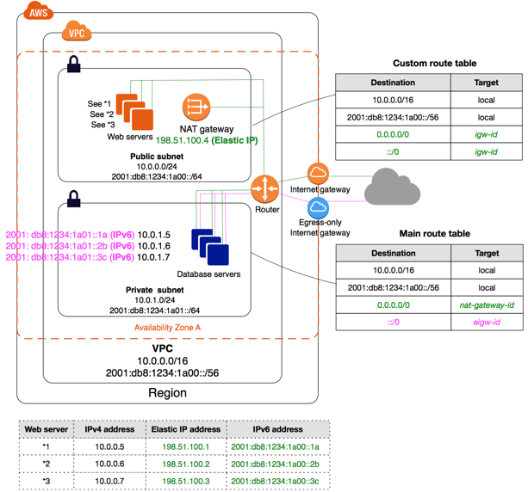

# Scenario 2: VPC with Public and Private Subnets (NAT)

The configuration for this scenario includes a virtual private cloud (VPC) with a public subnet and a private subnet. We recommend this scenario if you want to run a public-facing web application, while maintaining back-end servers that aren't publicly accessible. A common example is a multi-tier website, with the web servers in a public subnet and the database servers in a private subnet. You can set up security and routing so that the web servers can communicate with the database servers.

The instances in the public subnet can send outbound traffic directly to the Internet, whereas the instances in the private subnet can't. Instead, the instances in the private subnet can access the Internet by using a network address translation (NAT) gateway that resides in the public subnet. The database servers can connect to the Internet for software updates using the NAT gateway, but the Internet cannot establish connections to the database servers.

The key driver here is cost, so an awareness of cost is necessary to answer this. Full S3 is quite expensive at around $0.023 per GB for the lowest band. S3 standard IA is $0.0125 per GB, S3 One Zone-IA is $0.01 per GB, and Legacy S3-RRS is around $0.024 per GB for the lowest band. Of the offered solutions S3 One Zone-IA is the cheapest suitable option. Glacier cannot be considered as it is not intended for direct access, however it comes in at around $0.004 per GB.

For all new AWS accounts, there is a soft limit of 20 EC2 instances per region. You should submit the limit increase form and retry the template after your limit has been increased.

EC2 service limits affect one Region at a time, so request service limit increases in [each AWS region](https://docs.aws.amazon.com/general/latest/gr/rande.html) where you need more resources.

Amazon EC2 Spot Instances offer spare compute capacity available in the AWS cloud at steep discounts compared to On-Demand instances. Spot Instances enable you to optimize your costs on the AWS cloud and scale your application's throughput up to 10X for the same budget.  
  
Spot Instances can be interrupted by EC2 with two minutes of notification when EC2 needs the capacity back.

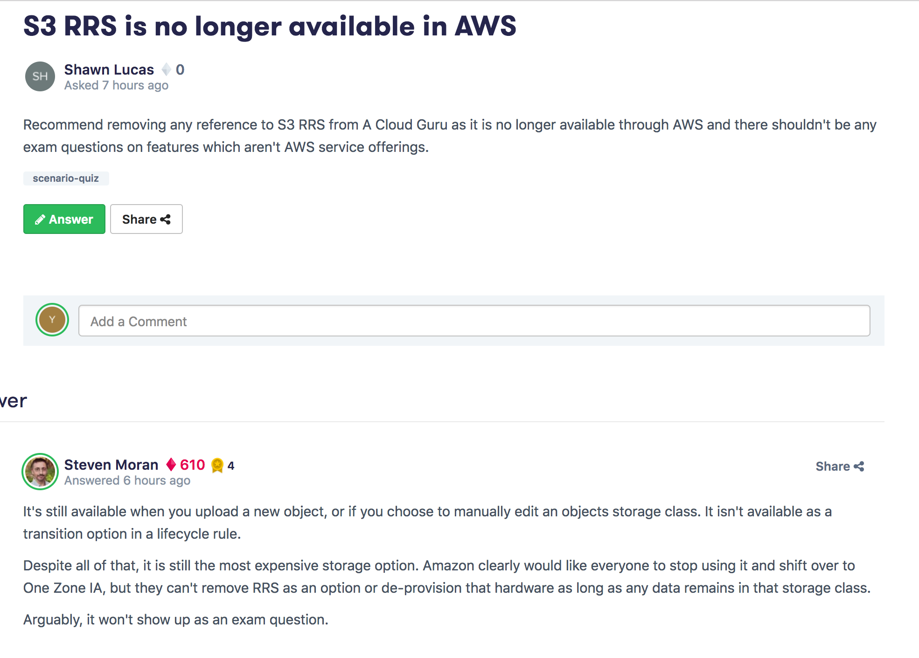

Recovery Point Objective (RPO) and Recovery Time Objective (RTO)

S3, SQS & DynamoDB are already built in a fault tolerant fashion, you do not need to provision these services across multiple availability zones. Therefore the correct answers are RDS and EC2

With proper scripting and scaling policies, the On-demand instances behind the Spot instances will deliver the most cost-effective solution because the on-demand will only spin up if the spot instances are not available. DynamoDB is a regional service, there is no need to explicitly create a multi-AZ deployment. RDS could be used, but DynamoDB lends itself better to supporting stateless web/app installations.

EBS volumes can be encrypted, but they are not encrypted by default. SSL certificates will only be useful to encrypt data in transit, not data at rest.

Volume Gateway – A volume gateway provides cloud-backed storage volumes that you can mount as Internet Small Computer System Interface (iSCSI) devices from your on-premises application servers. The gateway supports the following volume configurations:

* **Cached volumes** – You store your data in Amazon Simple Storage Service (Amazon S3) and retain a copy of frequently accessed data subsets locally. Cached volumes offer a substantial cost savings on primary storage and minimize the need to scale your storage on-premises. You also retain low-latency access to your frequently accessed data.
* **Stored volumes** – If you need low-latency access to your entire dataset, first configure your on-premises gateway to store all your data locally. Then asynchronously back up point-in-time snapshots of this data to Amazon S3. This configuration provides durable and inexpensive offsite backups that you can recover to your local data center or Amazon EC2. For example, if you need replacement capacity for disaster recovery, you can recover the backups to Amazon EC2.

**Tape Gateway** – With a tape gateway, you can cost-effectively and durably archive backup data in Amazon Glacier. A tape gateway provides a virtual tape infrastructure that scales seamlessly with your business needs and eliminates the operational burden of provisioning, scaling, and maintaining a physical tape infrastructure.

The [*file gateway*](https://aws.amazon.com/storagegateway/file/) enables you to store and retrieve objects in Amazon S3 using file protocols, such as NFS. Objects written through file gateway can be directly accessed in S3. File gateway presents a file-based interface to Amazon S3, which appears as a network file share.

The [*volume gateway*](https://aws.amazon.com/storagegateway/features/#volume-gateway) provides block storage to your applications using the iSCSI protocol. Data on the volumes is stored in Amazon S3. To access your iSCSI volumes in AWS, you can take EBS snapshots which can be used to create EBS volumes.

The [*tape gateway*](https://aws.amazon.com/storagegateway/vtl/) provides your backup application with an iSCSI virtual tape library (VTL) interface, consisting of a virtual media changer, virtual tape drives, and virtual tapes. Virtual tape data is stored in Amazon S3 or can be archived to Amazon Glacier. irtual tapes are available for immediate access and are backed by Amazon S3. You can also archive tapes. Archived tapes are stored in Amazon Glacier.

When a consumer receives and processes a message from a queue, the message remains in the queue. Amazon SQS doesn't automatically delete the message. Because Amazon SQS is a distributed system, there's no guarantee that the consumer actually receives the message (for example, due to a connectivity issue, or due to an issue in the consumer application). Thus, the consumer must delete the message from the queue after receiving and processing it.

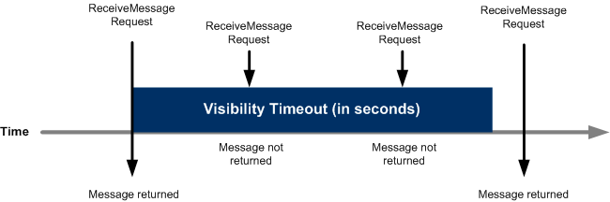

Immediately after a message is received, it remains in the queue. To prevent other consumers from processing the message again, Amazon SQS sets a *visibility timeout*, a period of time during which Amazon SQS prevents other consumers from receiving and processing the message. The default visibility timeout for a message is 30 seconds. The minimum is 0 seconds. The maximum is 12 hours.

For standard queues, the visibility timeout isn't a guarantee against receiving a message twice. For more information, see [At-Least-Once Delivery](https://docs.aws.amazon.com/AWSSimpleQueueService/latest/SQSDeveloperGuide/standard-queues.html#standard-queues-at-least-once-delivery).

The visibility timeout begins when Amazon SQS returns a message. During this time, the consumer processes and deletes the message. However, if the consumer fails before deleting the message and your system doesn't call the [DeleteMessage](https://docs.aws.amazon.com/AWSSimpleQueueService/latest/APIReference/API_DeleteMessage.html) action for that message before the visibility timeout expires, the message becomes visible to other consumers and the message is received again. If a message must be received only once, your consumer should delete it within the duration of the visibility timeout.

Every Amazon SQS queue has the default visibility timeout setting of 30 seconds. You can change this setting for the entire queue.

**X-Forwarded Headers**

* [X-Forwarded-For](https://docs.aws.amazon.com/elasticloadbalancing/latest/classic/x-forwarded-headers.html#x-forwarded-for)
* [X-Forwarded-Proto](https://docs.aws.amazon.com/elasticloadbalancing/latest/classic/x-forwarded-headers.html#x-forwarded-proto)
* [X-Forwarded-Port](https://docs.aws.amazon.com/elasticloadbalancing/latest/classic/x-forwarded-headers.html#x-forwarded-port)

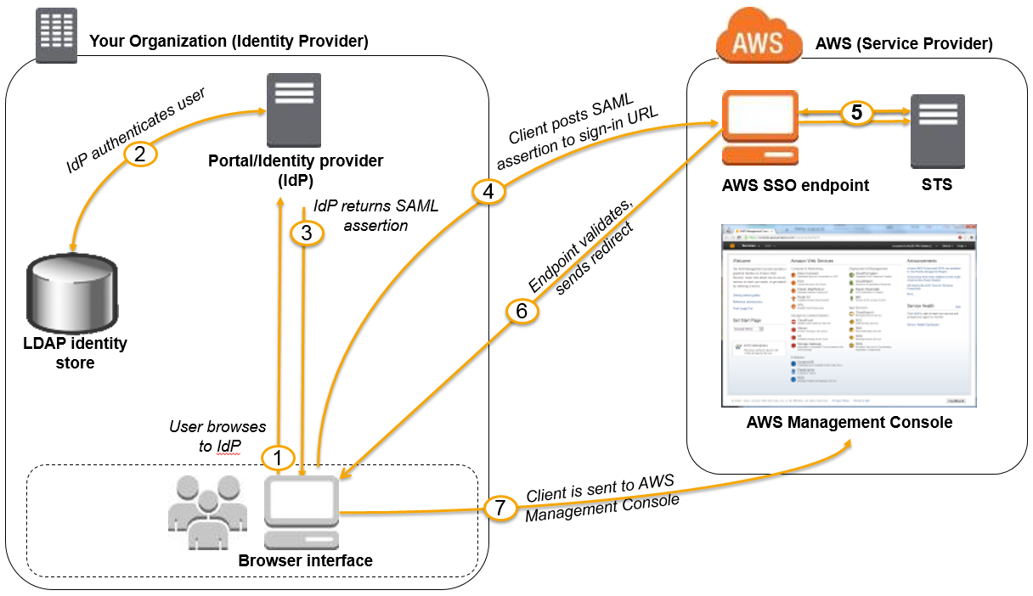

# Limits in DynamoDB

For any AWS account, there is an initial limit of 256 tables per region.

To request a service limit increase see <https://aws.amazon.com/support>.

The length of a String is constrained by the maximum item size of 400 KB.

The maximum item size in DynamoDB is 400 KB, which includes both attribute name binary length (UTF-8 length) and attribute value lengths (again binary length). The attribute name counts towards the size limit.

When reading data from DynamoDB, users can specify whether they want the read to be eventually consistent or strongly consistent:

* Eventually consistent reads (the default) – The eventual consistency option maximizes your read throughput. However, an eventually consistent read might not reflect the results of a recently completed write. All copies of data usually reach consistency within a second. Repeating a read after a short time should return the updated data.
* Strongly consistent reads — In addition to eventual consistency, DynamoDB also gives you the flexibility and control to request a strongly consistent read if your application, or an element of your application, requires it. A strongly consistent read returns a result that reflects all writes that received a successful response before the read.

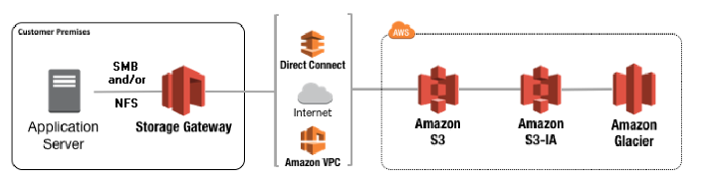

There are no charges for copying an AMI. However, standard storage and data transfer rates apply.

AWS does not copy launch permissions, user-defined tags, or Amazon S3 bucket permissions from the source AMI to the new AMI. After the copy operation is complete, you can apply launch permissions, user-defined tags, and Amazon S3 bucket permissions to the new AMI.

Using multipart upload provides the following advantages:

* Improved throughput - You can upload parts in parallel to improve throughput.
* Quick recovery from any network issues - Smaller part size minimizes the impact of restarting a failed upload due to a network error.
* Pause and resume object uploads - You can upload object parts over time. Once you initiate a multipart upload there is no expiry; you must explicitly complete or abort the multipart upload.
* Begin an upload before you know the final object size - You can upload an object as you are creating it.

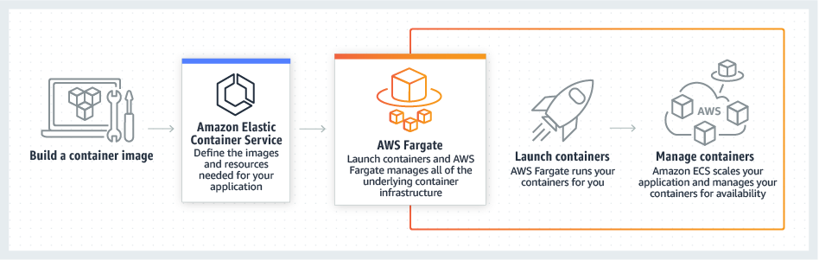

A /28 subnet will only have 16 addresses available. AWS reserve both the first four and last IP addresses in each subnet’s CIDR bl

The tenancy of an instance can only be change between variants of ‘dedicated' tenancy hosting. It cannot be changed from or to default tenancy hosting.

To route domain traffic to an ELB load balancer, use Amazon Route 53 to create an [alias record](https://docs.aws.amazon.com/Route53/latest/DeveloperGuide/resource-record-sets-choosing-alias-non-alias.html) that points to your load balancer. An alias record is a Route 53 extension to DNS. It's similar to a CNAME record, but you can create an alias record both for the root domain, such as example.com, and for subdomains, such as www.example.com.

The **A record** maps a name to one or more IP addresses, when the IP are known and stable. The **CNAME record** maps a name to another name.

1. Autoscaling - is pre-configured by you to automatically create more instances as, for example, your instance cpu usage exceeds 80%. It will create new instances up to the maximum you specified (example: minimum 1 instance, maximum 10 instances). Also you can set a trigger whereby if the load decreases, which can be seem by your cpu usage dropping below 25% for an instance then it will automatically terminate instances.

2. Proactive scaling - is also setup by you, whereby you change, for example, the number of your minimum instances from say 1 to maybe 5 for a period as you know there will be high demand (black friday is a nice example). This may be a better option for you than relying purely on the auto-scaling mechanism as there is a start-up time cost for each new instance when auto-scaling whereas if you know from past experience that you will need at least 5 machines during a period, starting them up before-hand softens the blow of a mass rush to you website or service.

 If you want to prevent your instance from being accidentally terminated using Amazon EC2, you can enable termination protection for the instance.

You can't enable termination protection for Spot instances — a Spot instance is terminated when the Spot price exceeds your bid price.

AWS has removed the Firewall appliance from the hub of the network and implemented the firewall functionality as stateful Security Groups, and stateless subnet NACLs.

EBS:

There is no direct way to encrypt an existing unencrypted volume, or to remove encryption from an encrypted volume. However, you can migrate data between encrypted and unencrypted volumes. You can also apply a new encryption status while copying a snapshot:

* While copying an unencrypted snapshot of an unencrypted volume, you can encrypt the copy. Volumes restored from this encrypted copy are also encrypted.
* While copying an encrypted snapshot of an encrypted volume, you can associate the copy with a different CMK. Volumes restored from the encrypted copy are only accessible using the newly applied CMK.

An Amazon EC2 Dedicated Host is a physical server with EC2 instance capacity fully dedicated to your use. Dedicated Hosts can help you address compliance requirements and reduce costs by allowing you to use your existing server-bound software licenses.

When you create each subnet, you provide the VPC ID and IPv4 CIDR block for the subnet. After you create a subnet, you can't change its CIDR block. AWS reserves both the first four and the last IPv4 address in each subnet's CIDR block. They're not available for use.

EC2 Key Pairs, Security Groups, and ELBs are region-specific.

Route53 has a security feature that prevents internal DNS from being read by external sources. The work around is to create a EC2 hosted DNS instance that does zone transfers from the internal DNS, and allows itself to be queried by external servers.

Route53 has the following routing policies - Simple, Weighted, Latency, Failover, and Geolocation

Trusted advisor: The correct answers are whether there is MFA configure on the Root Account and advice on security groups and what ports have unrestricted access.

AWS WAF is a web application firewall that lets you monitor the HTTP and HTTPS requests that are forwarded to Amazon CloudFront or an Application Load Balancer. AWS WAF also lets you control access to your content. Based on conditions that you specify, such as the IP addresses that requests originate from or the values of query strings, CloudFront or an Application Load Balancer responds to requests either with the requested content or with an HTTP 403 status code (Forbidden).

* [Step 2: Create a Web ACL](https://docs.aws.amazon.com/waf/latest/developerguide/getting-started.html#getting-started-wizard-create-web-acl)
* [Step 3: Create an IP Match Condition](https://docs.aws.amazon.com/waf/latest/developerguide/getting-started.html#getting-started-wizard-create-ip-condition)
* [Step 4: Create a Geo Match Condition](https://docs.aws.amazon.com/waf/latest/developerguide/getting-started.html#getting-started-wizard-create-geo-condition)
* [Step 5: Create a String Match Condition](https://docs.aws.amazon.com/waf/latest/developerguide/getting-started.html#getting-started-wizard-create-string-condition)
* [Step 5A: Create a Regex Condition (Optional)](https://docs.aws.amazon.com/waf/latest/developerguide/getting-started.html#getting-started-wizard-create-regex-condition)
* [Step 6: Create a SQL Injection Match Condition](https://docs.aws.amazon.com/waf/latest/developerguide/getting-started.html#getting-started-wizard-create-sql-condition)

Network Access Control Lists are stateless; updates are applied near instantaneously.

VPC peering only routes traffic between source and destination VPCs. VPC peering does not support edge to edge routing.

You need to ensure that your application in your custom VPC can communicate back to the on-premise data center. You can do this by either using a site to site VPN or Direct Connect. It will be using an internal IP address range, so you must make sure that your internal IP addresses do not overlap.

The correct answers are Enterprise, Business, Developer. Plus the Basic free level. Remember that Free Tier is a Billing rebate not an account or support level.

The default cooldown period is applied when you create your Auto Scaling group. Its default value is 300 seconds.

f you have CloudWatch alarms associated with your Auto Scaling group, use the [put-metric-alarm](https://docs.aws.amazon.com/cli/latest/reference/cloudwatch/put-metric-alarm.html) command to update each alarm so that its period matches the monitoring type (300 seconds for basic monitoring and 60 seconds for detailed monitoring).

* Application Load Balancers allow containers to use dynamic host port mapping (so that multiple tasks from the same service are allowed per container instance).
* Application Load Balancers support path-based routing and priority rules (so that multiple services can use the same listener port on a single Application Load Balancer).

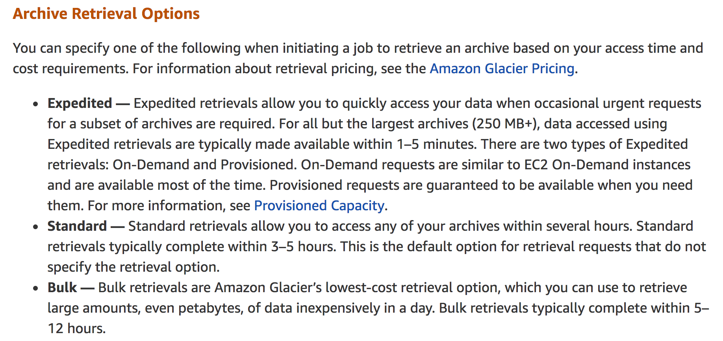

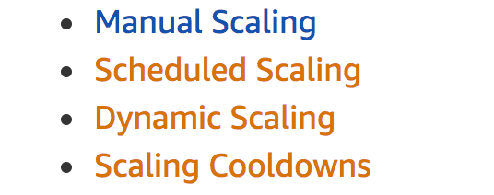

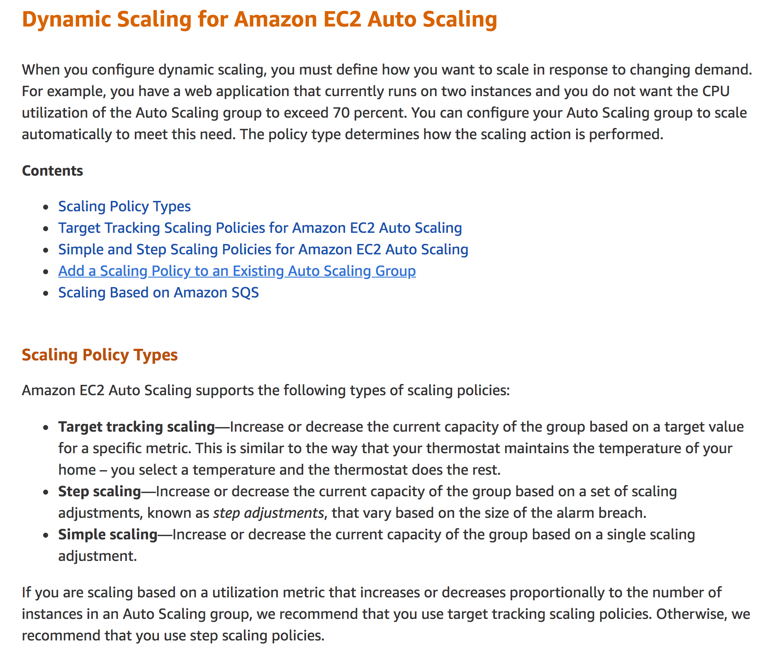

Amazon Virtual Private Cloud provides features that you can use to increase and monitor the security for your virtual private cloud (VPC):

* Security groups — Act as a firewall for associated Amazon EC2 instances, controlling both inbound and outbound traffic at the instance level
* Network access control lists (ACLs) — Act as a firewall for associated subnets, controlling both inbound and outbound traffic at the subnet level
* Flow logs — Capture information about the IP traffic going to and from network interfaces in your VPC

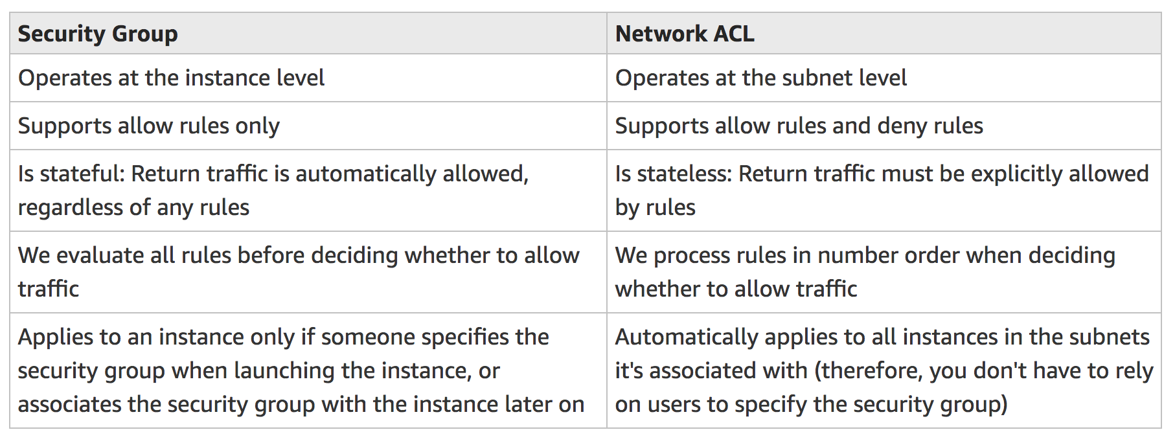







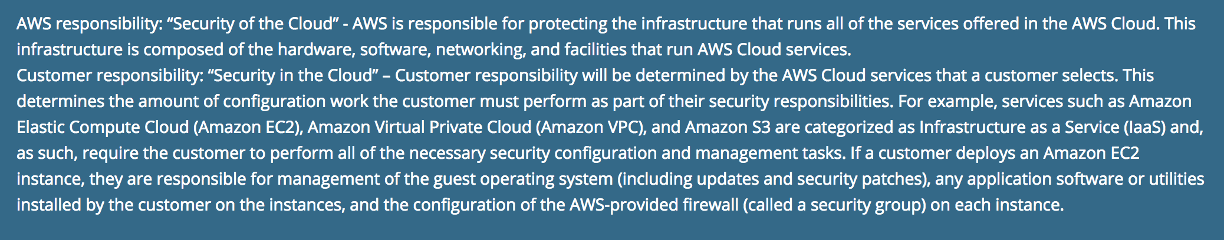

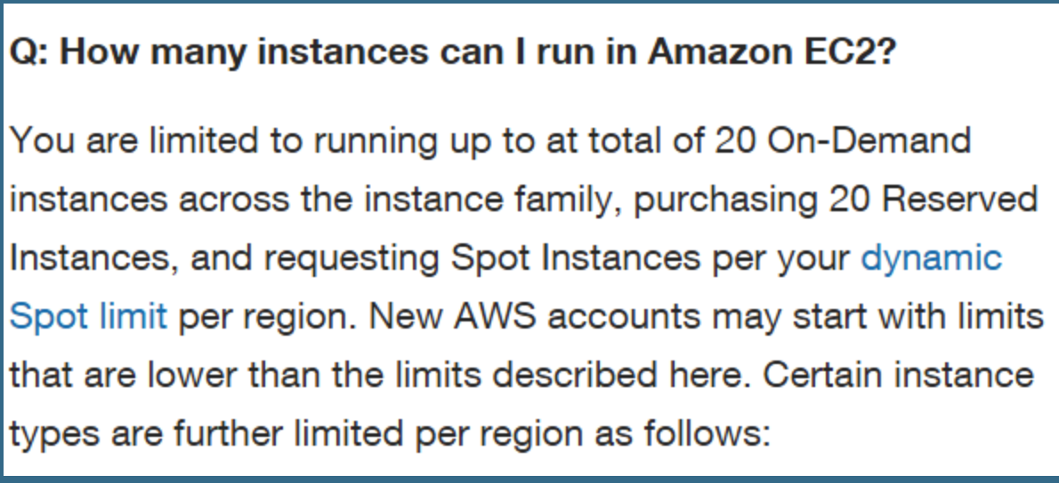

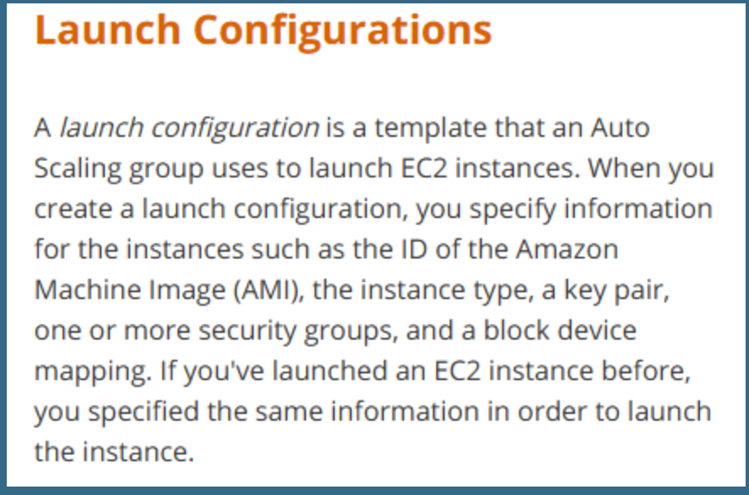

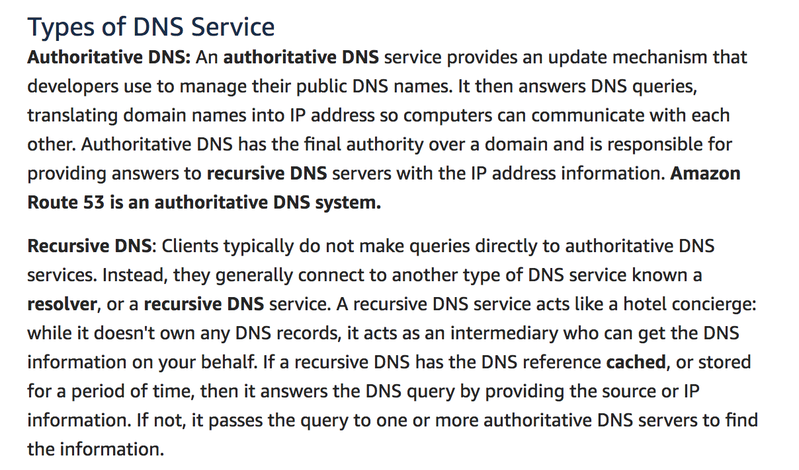

Route 53: a record set can only have one alias target

CName doesn’t have the option of Alias or Alias Target (CName only for RDS)

CName: [www.google.com](http://www.google.com) <=> google.com (zone apex is the one without www, or root domain), alternative domain name, is used to change domain name. CName cannot change the root domain (zone apex). CName is used for changing subdomains or suffix.

A: IPV4 address

IP: google.com <=> xxx.gssds.coms (for all other services)

The DNS protocol does not allow you to create a CNAME record for the top node of a DNS namespace, also known as the zone apex. For example, if you register the DNS name example.com, the zone apex is example.com. You cannot create a CNAME record for example.com, but you can create CNAME records for www.example.com, newproduct.example.com, and so on.

In addition, if you create a CNAME record for a subdomain, you cannot create any other records for that subdomain. For example, if you create a CNAME for www.example.com, you cannot create any other records for which the value of the Name field is [www.example.com](http://www.example.com).

The problem is the DNS RFC (RFC1033) requires the "zone apex" (sometimes called the "root domain" or "naked domain") to be an "A Record," not a CNAME. This means that with most DNS providers you can setup a subdomain CNAME to point to EC2, but you cannot setup your root domain as a CNAME  
to point to EC2.

Alias is always YES working with A type.

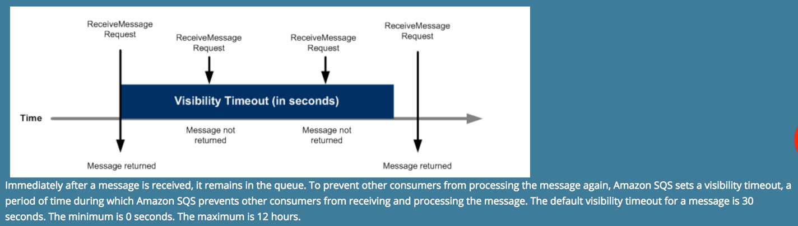

Permission is existed on the SQS queue level, not on the message level

Delete/Send/ChangeVisibiliy in SQS can be done in the batch manner

ReceiptHandle is used for deleting the message in the SQS

SQS IS NOT encrypted by default

STS: AssumeRole is used to get federated/single account access credential files for IAM user or role

STS: when getting tokens, must pass an IAM user json document

An IAM [role](https://docs.aws.amazon.com/IAM/latest/UserGuide/id_roles.html) is very similar to a user, in that it is an identity with permission policies that determine what the identity can and cannot do in AWS. However, a role does not have any credentials (password or access keys) associated with it. Instead of being uniquely associated with one person, a role is intended to be assumable by anyone who needs it. An IAM user can assume a role to temporarily take on different permissions for a specific task. A role can be assigned to a [federated user](https://docs.aws.amazon.com/IAM/latest/UserGuide/id_roles_providers.html) who signs in by using an external identity provider instead of IAM. AWS uses details passed by the identity provider to determine which role is mapped to the federated user.

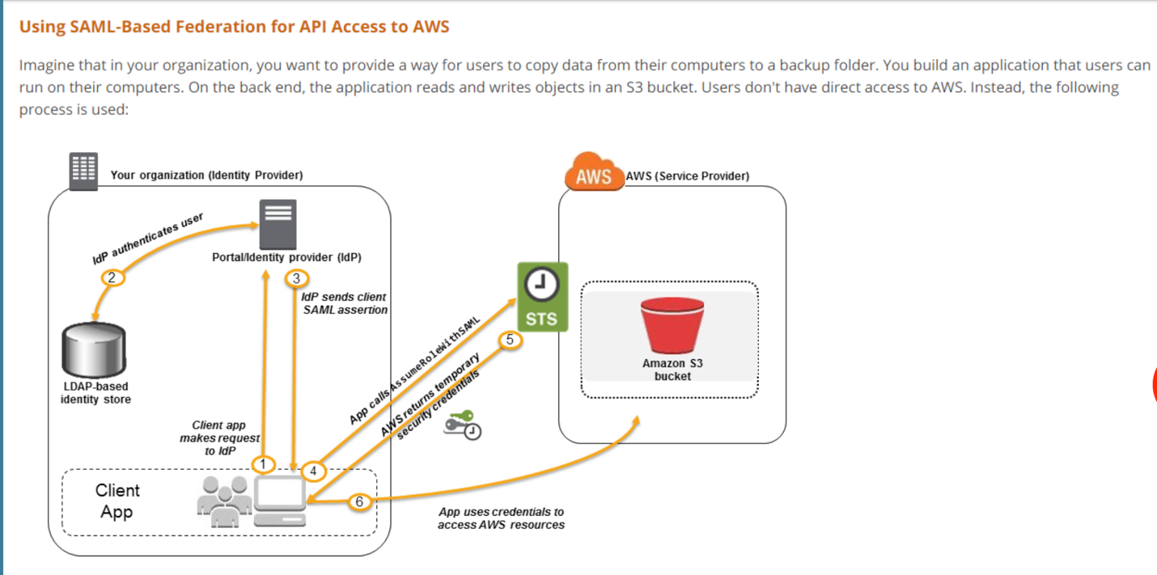

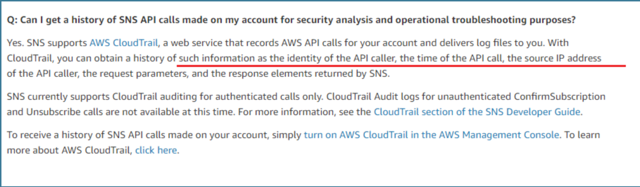

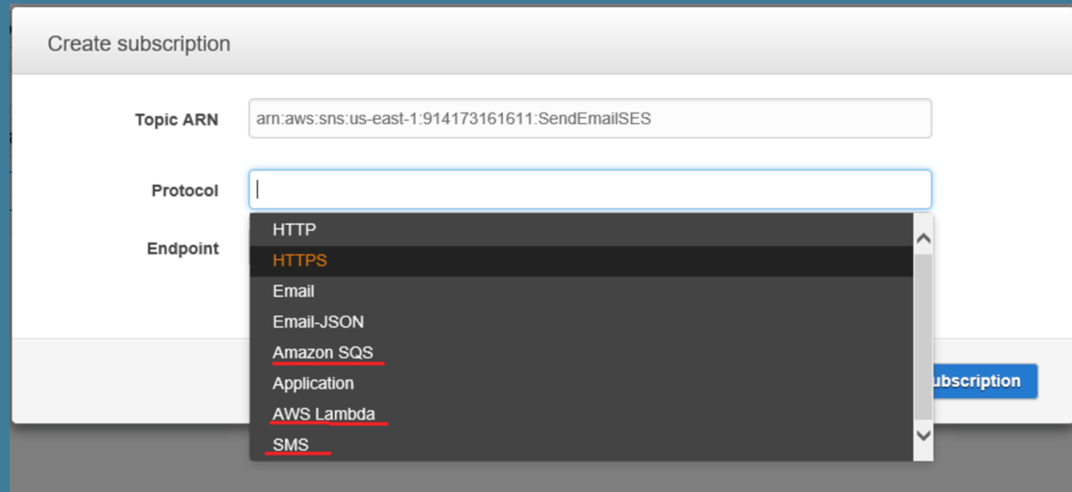

SNS: name, value, type

EBS: multiple volumes to one instance, can be changed in the runtime. Persist always, deleted by default during termination, but can be altered. Encryption supported on only certain instances

Instance store cannot be changed during runtime. Only persist during start and reboot. Only certain instances have instance store, up to 24

New Linux kernel and raid 0 can improve IO

Provisioned IOPS is for database

Encryption on EBS cannot be changed after launched, so it can be enabled during copying files

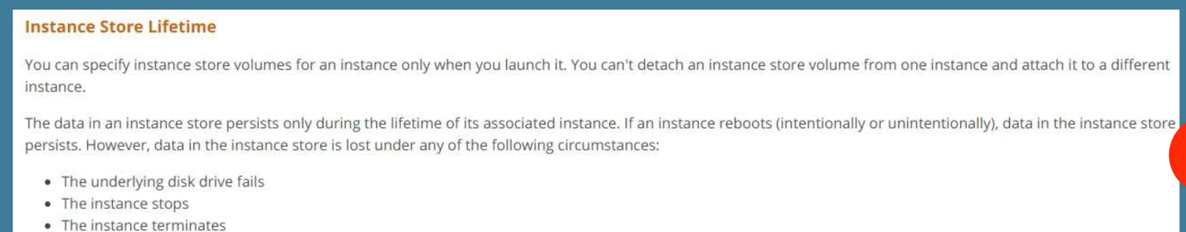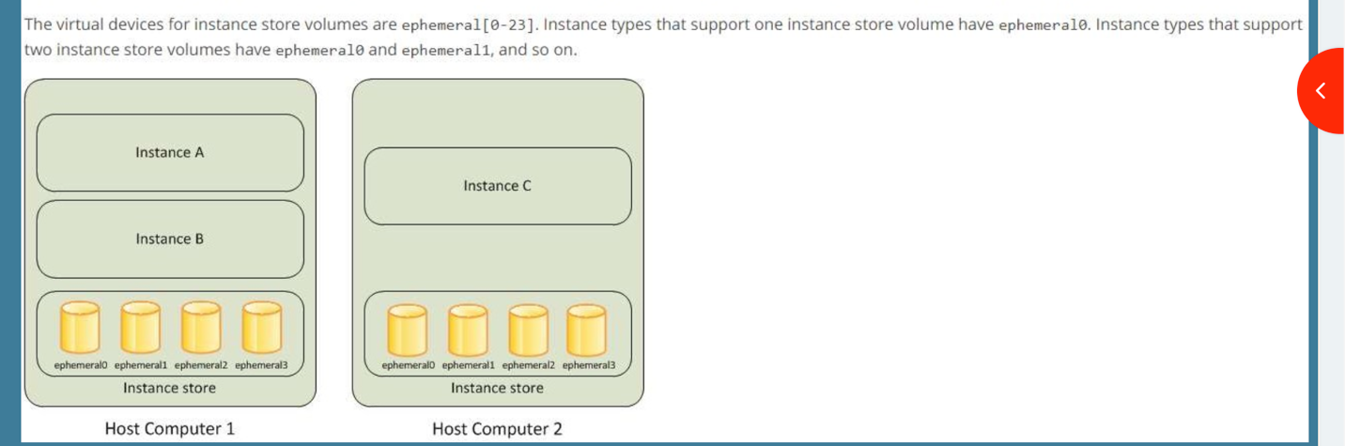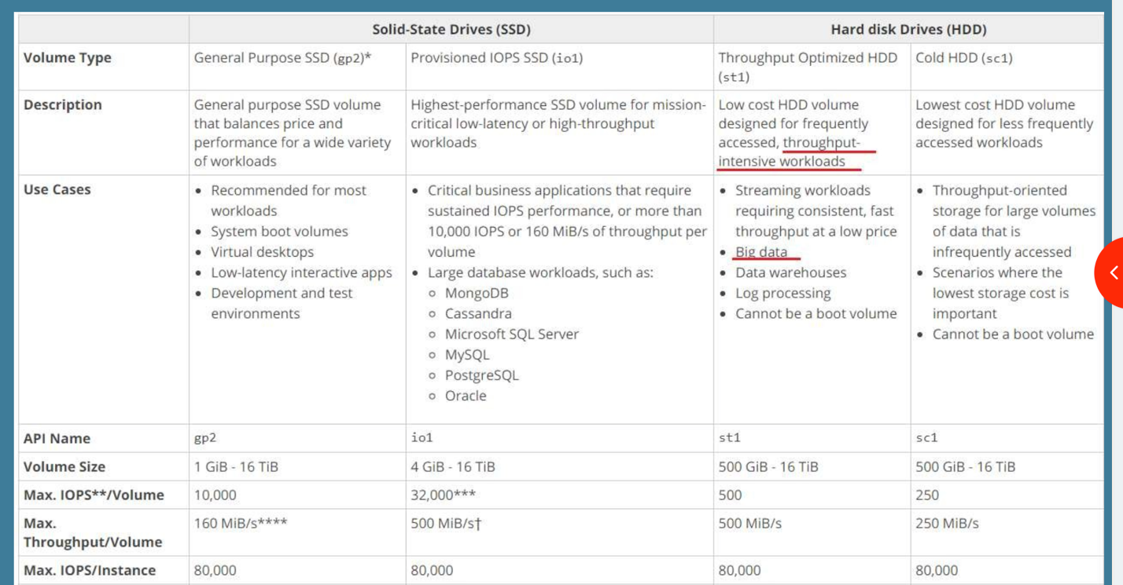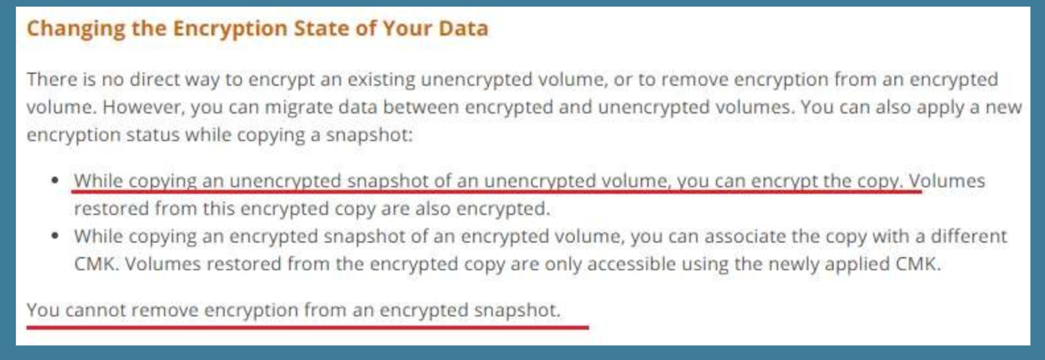

Amazon ECS and EKS have two modes: Fargate launch type and EC2 launch type. With Fargate launch type, all you have to do is package your application in containers, specify the CPU and memory requirements, define networking and IAM policies, and launch the application. EC2 launch type allows you to have server-level, more granular control over the infrastructure that runs your container applications.

The Fargate launch type only supports using container images hosted in Amazon ECR or publicly on Docker Hub. Private repositories are currently only supported using the EC2 launch type.

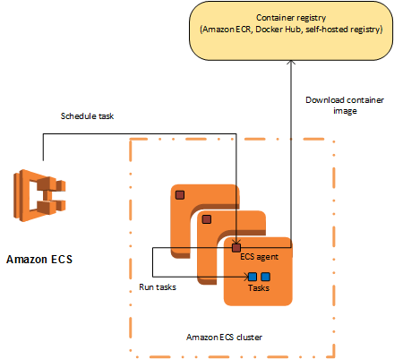

ECS: user has the root permission for the managed EC2 instance

A VPC endpoint enables you to privately connect your VPC to supported AWS services and VPC endpoint services powered by PrivateLink without requiring an internet gateway, NAT device, VPN connection, or AWS Direct Connect connection. Instances in your VPC do not require public IP addresses to communicate with resources in the service. Traffic between your VPC and the other service does not leave the Amazon network.

ECS needs NAT Gateway to communicate out, and VPC endpoint now is not supportive yet. ECS or ECS agent also need to follow network access control and security group rule, and IAM role.

If your container instance was launched with the Amazon ECS-optimized AMI, you can set these environment variables in the /etc/ecs/ecs.config file and then restart the agent. You can also write these configuration variables to your container instances with Amazon EC2 user data at launch time.

Your container instance must be running the Amazon ECS container agent to register into one of your clusters. If you are using the Amazon ECS-optimized AMI, the agent is already installed.

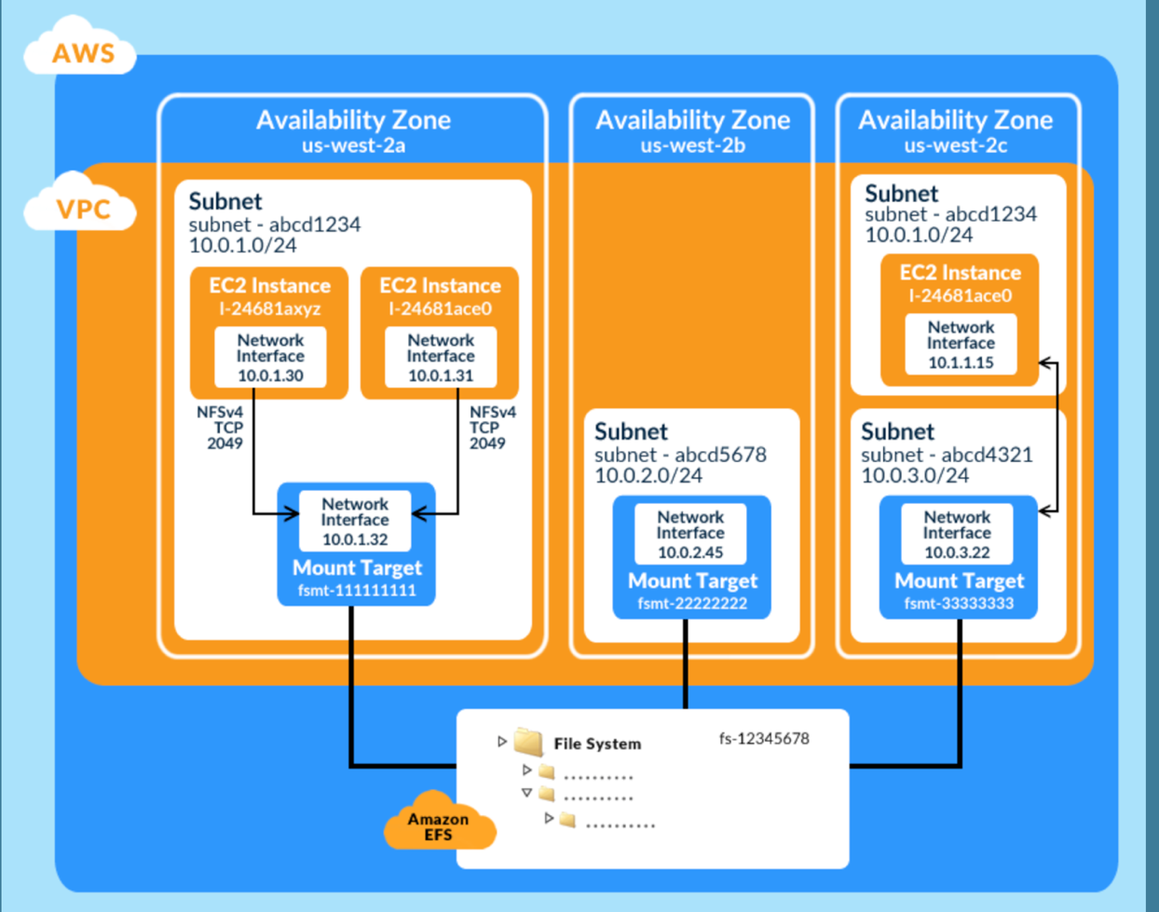

One EFS can only be used for one VPC, unless using VPC peering with certain type EC2 instance

EC2 SSH22, EFS 2049 NFS SSH

Only one mount target exists in one subnet. Creating a new mount target takes into effect immediately.

VPC-peering for EFS is only okay for one region.

NFS protocol for data transmission is not encrypted.

Max IO has high latency, used for 100 EC2

There are two throughput modes to choose from for your file system, Bursting Throughput and Provisioned Throughput. With *Bursting Throughput* mode, throughput on Amazon EFS scales as your file system grows. With *Provisioned Throughput*mode, you can instantly provision the throughput of your file system (in MiB/s) independent of the amount of data stored.

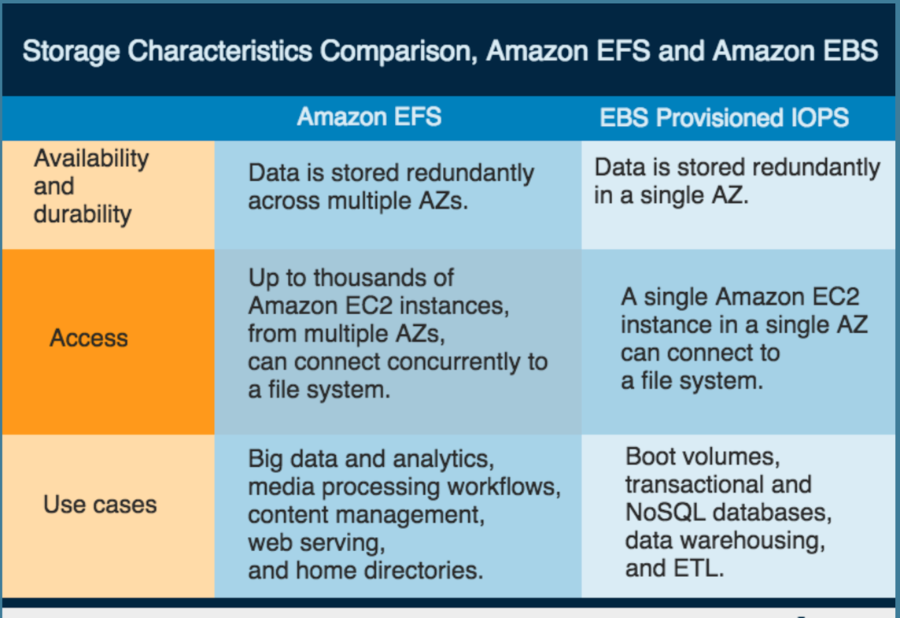

Gateway: AWS Service, VPC link, http(s), Lambda

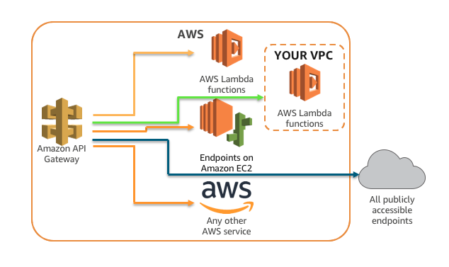

All of these below are not by default. Only DDOS is default protection

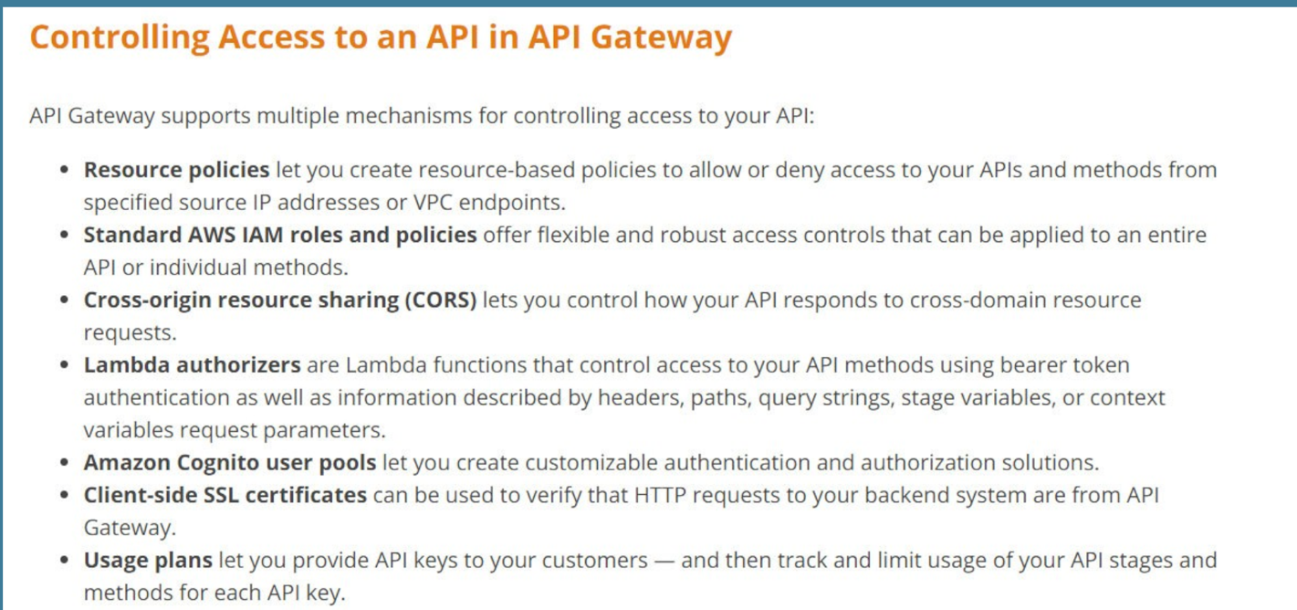

If throttling is more than steady and burst one, it will return 429

Throttling can be done on method level

Gateway log ip address of requester down

If an instance becomes unhealthy, the autoscaling group terminates the unhealthy instance and launches another instance to replace it

You can specify your launch configuration with multiple Auto Scaling groups. However, you can only specify one launch configuration for an Auto Scaling group at a time, and you can't modify a launch configuration after you've created it. Therefore, if you want to change the launch configuration for an Auto Scaling group, you must create a launch configuration and then update your Auto Scaling group with the new launch configuration.

Keep in mind that whenever you create an Auto Scaling group, you must specify a launch configuration, a launch template, or an EC2 instance. When you create an Auto Scaling group using an EC2 instance, Amazon EC2 Auto Scaling automatically creates a launch configuration for you and associates it with the Auto Scaling group

The cooldown period is a configurable setting for your Auto Scaling group that helps to ensure that it doesn't launch or terminate additional instances before the previous scaling activity takes effect. After the Auto Scaling group dynamically scales using a simple scaling policy, it waits for the cooldown period to complete before resuming scaling activities.

When you manually scale your Auto Scaling group, the default is not to wait for the cooldown period, but you can override the default and honor the cooldown period. If an instance becomes unhealthy, the Auto Scaling group does not wait for the cooldown period to complete before replacing the unhealthy instance.

Amazon EC2 Auto Scaling supports both default cooldown periods and scaling-specific cooldown periods.

Amazon EC2 Auto Scaling determines the health status of an instance using one or more of the following:

* Status checks provided by Amazon EC2 (systems status checks and instance status checks (default)
* Health checks provided by Elastic Load Balancing.

**Health Check Grace Period**

Frequently, an Auto Scaling instance that has just come into service needs to warm up before it can pass the health check. Amazon EC2 Auto Scaling waits until the health check grace period ends before checking the health status of the instance. While the EC2 status checks and ELB health checks can complete before the health check grace period expires, Amazon EC2 Auto Scaling does not act on them until the health check grace period expires. To provide ample warm-up time for your instances, ensure that the health check grace period covers the expected startup time for your application.

Amazon EC2 Auto Scaling supports the following custom termination policies:

* OldestInstance. Terminate the oldest instance in the group. This option is useful when you're upgrading the instances in the Auto Scaling group to a new EC2 instance type. You can gradually replace instances of the old type with instances of the new type.
* NewestInstance. Terminate the newest instance in the group. This policy is useful when you're testing a new launch configuration but don't want to keep it in production.
* OldestLaunchConfiguration. Terminate instances that have the oldest launch configuration. This policy is useful when you're updating a group and phasing out the instances from a previous configuration.
* ClosestToNextInstanceHour. Terminate instances that are closest to the next billing hour. This policy helps you maximize the use of your instances and manage your Amazon EC2 usage costs.
* Default. Terminate instances according to the default termination policy. This policy is useful when you have more than one scaling policy for the group.

**Default Termination Policy**

The default termination policy is designed to help ensure that your network architecture spans Availability Zones evenly. With the default termination policy, the behavior of the Auto Scaling group is as follows:

1. If there are instances in multiple Availability Zones, select the Availability Zone with the most instances and at least one instance that is not protected from scale in. If there is more than one Availability Zone with this number of instances, select the Availability Zone with the instances that use the oldest launch configuration.
2. Determine which unprotected instances in the selected Availability Zone use the oldest launch configuration. If there is one such instance, terminate it.
3. If there are multiple instances that use the oldest launch configuration, determine which unprotected instances are closest to the next billing hour. (This helps you maximize the use of your EC2 instances and manage your Amazon EC2 usage costs.) If there is one such instance, terminate it.
4. If there is more than one unprotected instance closest to the next billing hour, select one of these instances at random.

Each load balancer node routes requests only to the healthy targets in the enabled Availability Zones for the load balancer. Each load balancer node checks the health of each target, using the health check settings for the target group with which the target is registered. After your target is registered, it must pass one health check to be considered healthy. After each health check is completed, the load balancer node closes the connection that was established for the health check. If no Availability Zone contains a healthy target, the load balancer nodes route requests to all targets.

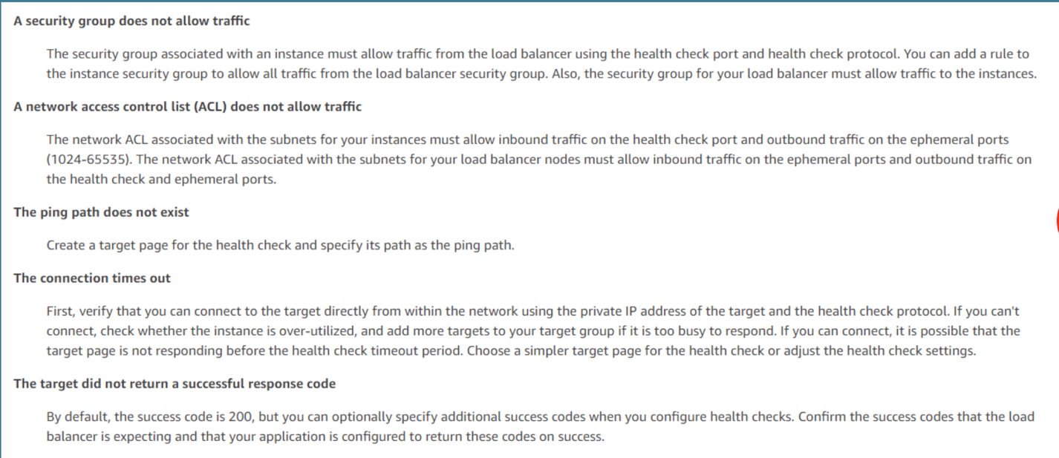

**Availability Zones and Load Balancer Nodes**

When you enable an Availability Zone for your load balancer, Elastic Load Balancing creates a load balancer node in the Availability Zone. If you register targets in an Availability Zone but do not enable the Availability Zone, these registered targets do not receive traffic. Note that your load balancer is most effective if you ensure that each enabled Availability Zone has at least one registered target.

We recommend that you enable multiple Availability Zones. (Note that with an Application Load Balancer, we require you to enable multiple Availability Zones.) With this configuration, if one Availability Zone becomes unavailable or has no healthy targets, the load balancer can continue to route traffic to the healthy targets in another Availability Zone.

After you disable an Availability Zone, the targets in that Availability Zone remain registered with the load balancer, but the load balancer will not route traffic to them.

Cross-zone enabled

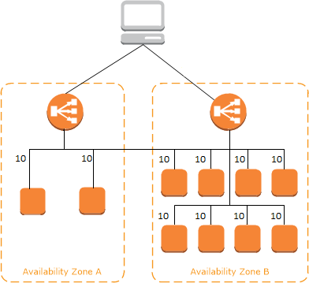

cross zone disabled

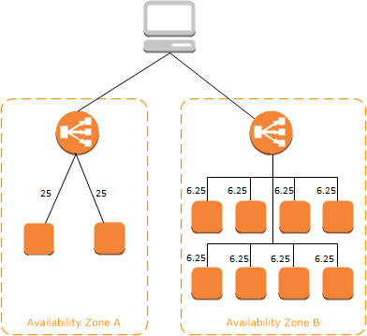

ALB monitoring: **CloudWatch metrics, Access logs, Request tracing, CloudTrail logs**

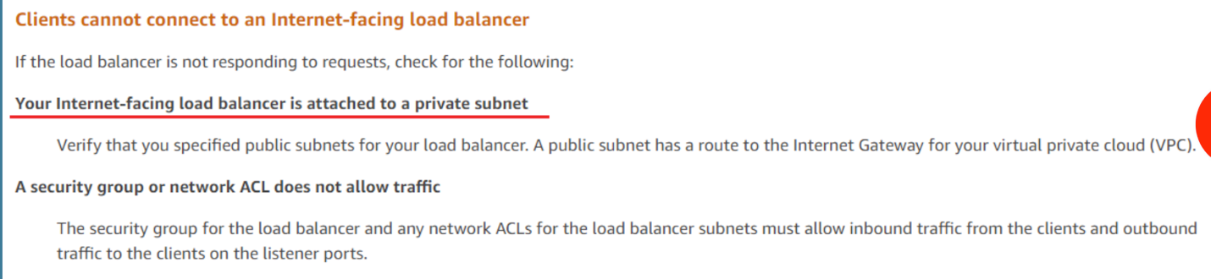

registration on ALB needs the id and ip of the ec2 instance

default s3 doesn’t have encryption, versioning, and transfer acceleration

S3 bucket properties

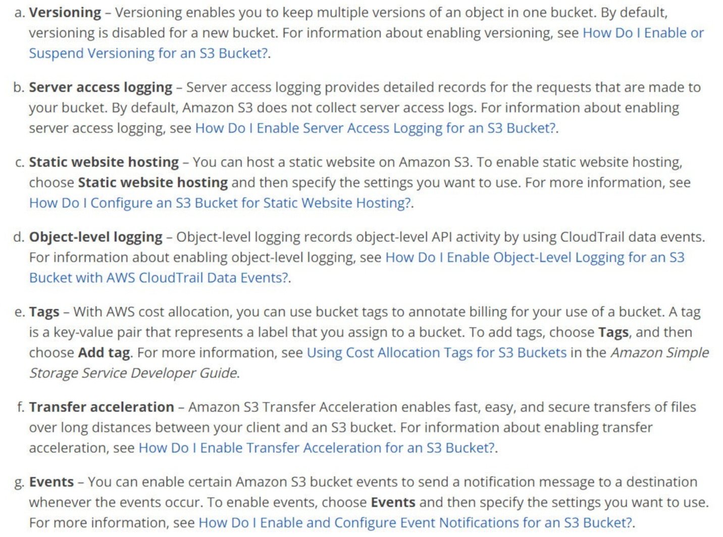

Storage class: object level

system metadata and user-defined metadata: object level

Amazon S3 provides read-after-write consistency for PUTS of new objects in your S3 bucket in all regions with one caveat. The caveat is that if you make a HEAD or GET request to the key name (to find if the object exists) before creating the object, Amazon S3 provides eventual consistency for read-after-write.

Amazon S3 offers eventual consistency for overwrite PUTS and DELETES in all regions.

DynamoDB: "A strongly consistent read returns a result that reflects all writes that received a successful response prior to the read."

S3: "Amazon S3 buckets in all Regions provide read-after-write consistency for PUTS of new objects and eventual consistency for overwrite PUTS and DELETES."

There are a couple of general differences, in that there are consistency options for DynamoDB, where as S3 is what it is. Also, as detailed above S3 consistency is dependent on the object being new or overwritten.

The DELETE operation removes the null version (if there is one) of an object and inserts a delete marker, which becomes the current version of the object. If there isn't a null version, Amazon S3 does not remove any objects.

Amazon EFS provides the open-after-close consistency semantics that applications expect from NFS. Amazon EFS provides stronger consistency guarantees than open-after-close semantics depending on the access pattern. Applications that perform synchronous data access and perform non-appending writes will have read-after-write consistency for data access.

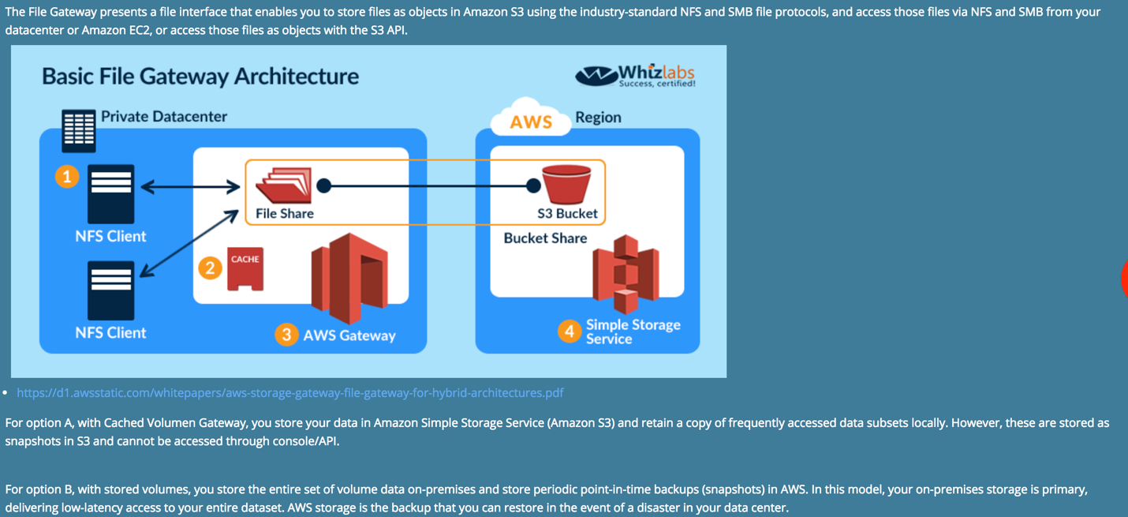

All objects by default are private. Only the object owner has permission to access these objects. However, the object owner can optionally share objects with others by creating a presigned URL, using their own security credentials, to grant time-limited permission to download the objects.

Randomize the prefix of each object key: will distribute evenly objects into several partitions, so better performance is there.

Single operation: up to 5g

Multipart operation: up to 5tb

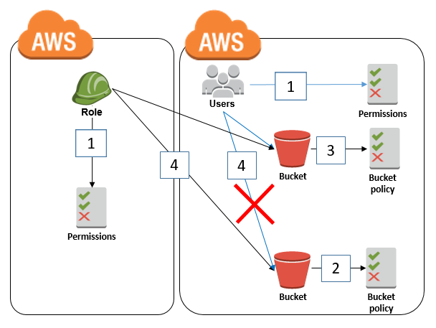

S3 is a managed service, so there is no concept of vpc and autoscaling

Standard: fast, highly available

Standard ia: less frequent access

Standard rrs: reduced redundancy

Metadata: date, content-length, last-modified, x-amz-server-side-encryption, x-amz-version-id, x-amz-delete-marker, x-amz-storage-class, x-amz-website-redirect-location, x-amz-server-side-encryption-aws-kms-key-id, x-amz-server-side-encryption-customer-algorithm

There is no extra charge for enabling server access logging on an Amazon S3 bucket; however, any log files that the system delivers to you accrue the usual charges for storage. The log bucket must be in the same account and region of the object bucket. You must grant the Log Delivery group write permission on the target bucket by adding a grant entry in the bucket's access control list (ACL).

http://*bucket*.s3-*aws-region*.amazonaws.com.

http://s3-*aws-region*.amazonaws.com/*bucket*



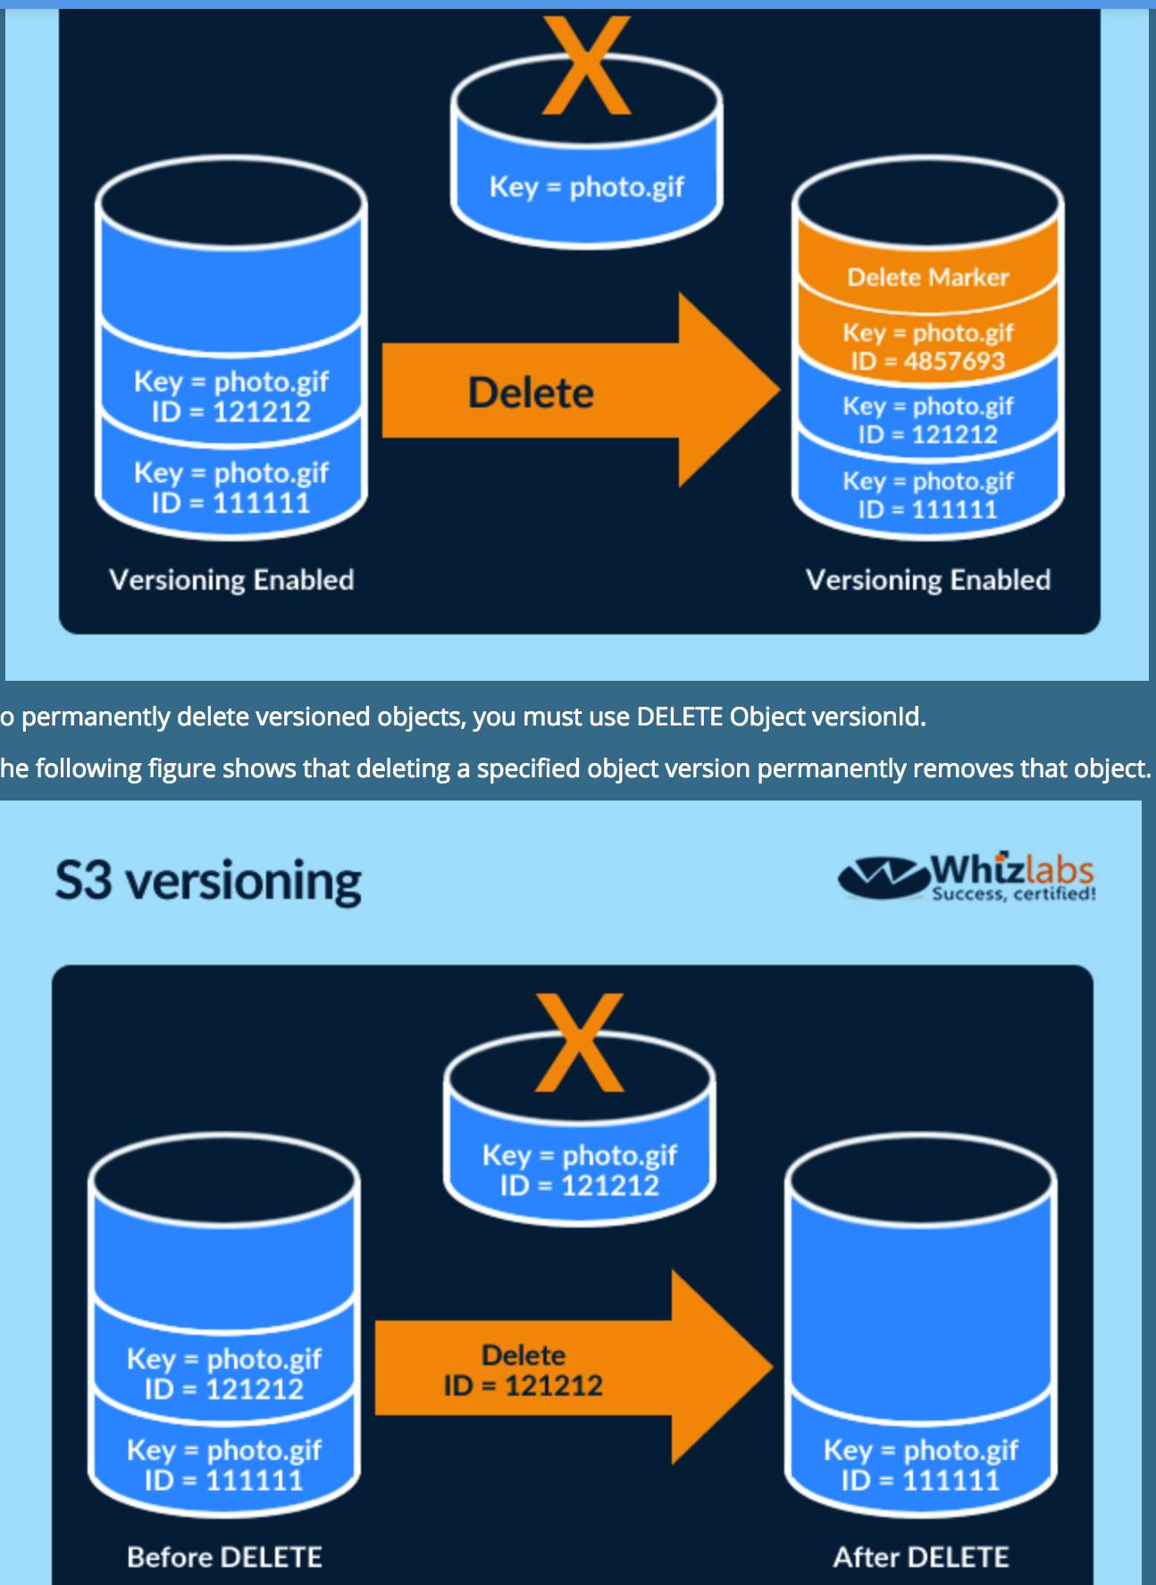

You might want to use Transfer Acceleration on a bucket for various reasons, including the following:

* You have customers that upload to a centralized bucket from all over the world.
* You transfer gigabytes to terabytes of data on a regular basis across continents.
* You are unable to utilize all of your available bandwidth over the Internet when uploading to Amazon S3.

Cross region replication: source and target bucket must have versioning on

You cannot create a VPC peering connection between VPCs with matching or overlapping IPv4 CIDR blocks.

You have a VPC peering connection between VPC A and VPC B (pcx-aaaabbbb), and between VPC A and VPC C (pcx-aaaacccc). There is no VPC peering connection between VPC B and VPC C. You cannot route packets directly from VPC B to VPC C through VPC A.

If either VPC in a peering relationship has one of the following connections, you cannot extend the peering relationship to that connection:

* A VPN connection or an AWS Direct Connect connection to a corporate network
* An internet connection through an internet gateway
* An internet connection in a private subnet through a NAT device
* A VPC endpoint to an AWS service; for example, an endpoint to Amazon S3.

You can use a NAT device to enable instances in a private subnet to connect to the internet (for example, for software updates) or other AWS services, but prevent the internet from initiating connections with the instances. NAT devices are not supported for IPv6 traffic—use an egress-only Internet gateway instead. To create a NAT gateway, you must specify the public subnet in which the NAT gateway should reside. You must also specify an [Elastic IP address](https://docs.aws.amazon.com/vpc/latest/userguide/vpc-eips.html) to associate with the NAT gateway when you create it.

Each subnet in your VPC must be associated with a route table; the table controls the routing for the subnet. A subnet can only be associated with one route table at a time, but you can associate multiple subnets with the same route table.

* Your VPC has an implicit router.
* Your VPC automatically comes with a main route table that you can modify.
* You can create additional custom route tables for your VPC.
* Each subnet must be associated with a route table, which controls the routing for the subnet. If you don't explicitly associate a subnet with a particular route table, the subnet is implicitly associated with the main route table.
* You cannot delete the main route table, but you can replace the main route table with a custom table that you've created (so that this table is the default table each new subnet is associated with).

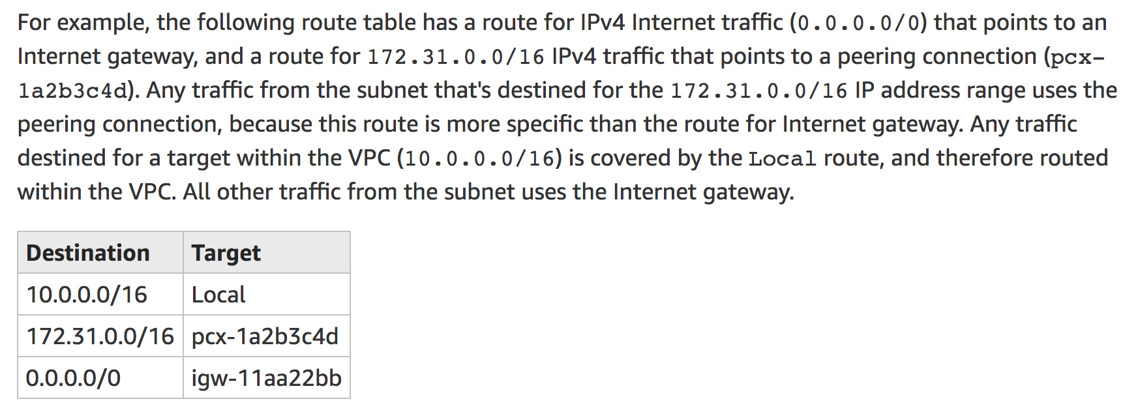

NAT gateway in public subnet: unidirectional to internet or other aws services

IGW: bidirectional to internet

Local VPC routing: the rule cannot be modified or deleted after creation

Your VPC automatically comes with a modifiable default network ACL. By default, it allows all inbound and outbound IPv4 traffic and, if applicable, IPv6 traffic.

* Each subnet in your VPC must be associated with a network ACL. If you don't explicitly associate a subnet with a network ACL, the subnet is automatically associated with the default network ACL.
* You can associate a network ACL with multiple subnets; however, a subnet can be associated with only one network ACL at a time. When you associate a network ACL with a subnet, the previous association is removed.
* Network ACLs are stateless; responses to allowed inbound traffic are subject to the rules for outbound traffic (and vice versa).

The default network ACL is configured to allow all traffic to flow in and out of the subnets to which it is associated. Each network ACL also includes a rule whose rule number is an asterisk. This rule ensures that if a packet doesn't match any of the other numbered rules, it's denied. You can't modify or remove this rule.

 When you launch an instance in a VPC, you can assign up to five security groups to the instance. Security groups act at the instance level, not the subnet level.

* You can specify allow rules, but not deny rules.
* You can specify separate rules for inbound and outbound traffic.
* When you create a security group, it has no inbound rules. Therefore, no inbound traffic originating from another host to your instance is allowed until you add inbound rules to the security group.
* By default, a security group includes an outbound rule that allows all outbound traffic. You can remove the rule and add outbound rules that allow specific outbound traffic only. If your security group has no outbound rules, no outbound traffic originating from your instance is allowed.
* Security groups are stateful — if you send a request from your instance, the response traffic for that request is allowed to flow in regardless of inbound security group rules. Responses to allowed inbound traffic are allowed to flow out, regardless of outbound rules.
* Security groups are associated with network interfaces. After you launch an instance, you can change the security groups associated with the instance, which changes the security groups associated with the primary network interface (eth0). You can also change the security groups associated with any other network interface.

When creating public/private subnet, if there is no route table explicitly created, it will be attached to main table. However, main table doesn’t have igw record by default.

An Elastic IP address is a public IPv4 address, which is reachable from the internet. If your instance does not have a public IPv4 address, you can associate an Elastic IP address with your instance to enable communication with the internet; for example, to connect to your instance from your local computer.

We currently do not support Elastic IP addresses for IPv6.

NAT cannot be created without elastic IP or public IP

A VPC endpoint enables you to privately connect your VPC to supported AWS services and VPC endpoint services powered by PrivateLink without requiring an internet gateway, NAT device, VPN connection, or AWS Direct Connect connection. Instances in your VPC do not require public IP addresses to communicate with resources in the service. Traffic between your VPC and the other service does not leave the Amazon network.

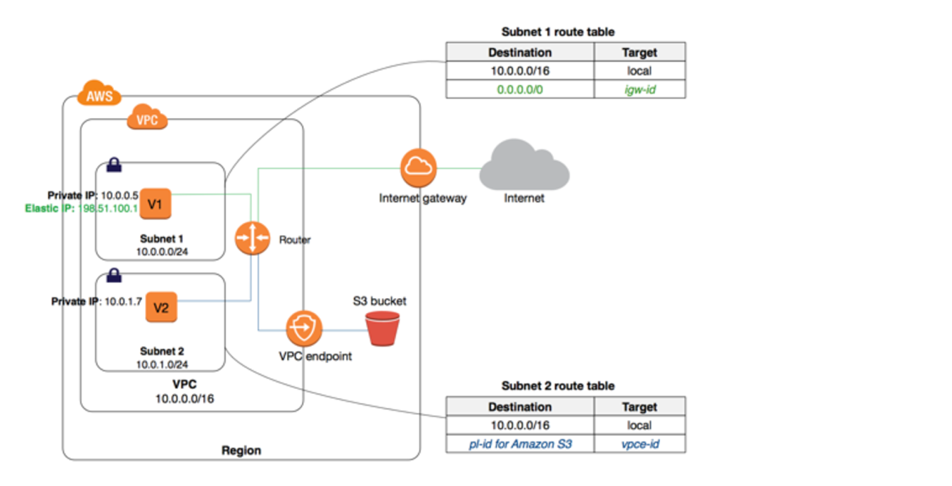

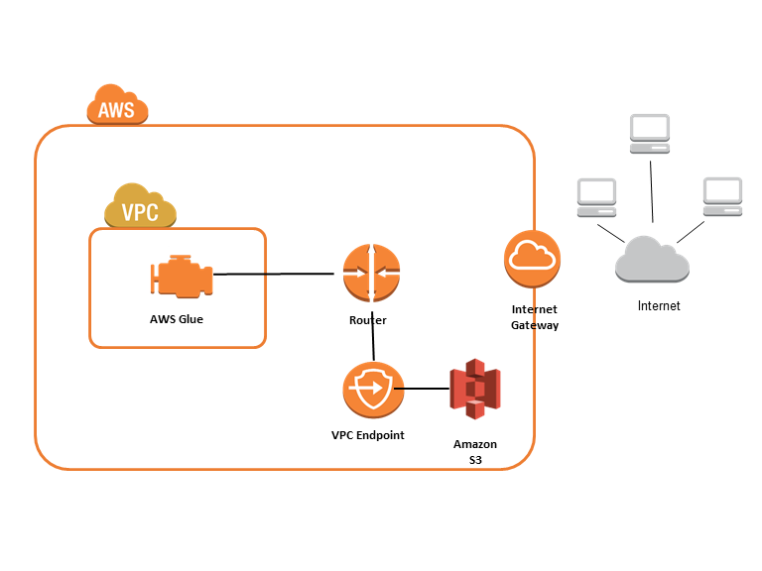

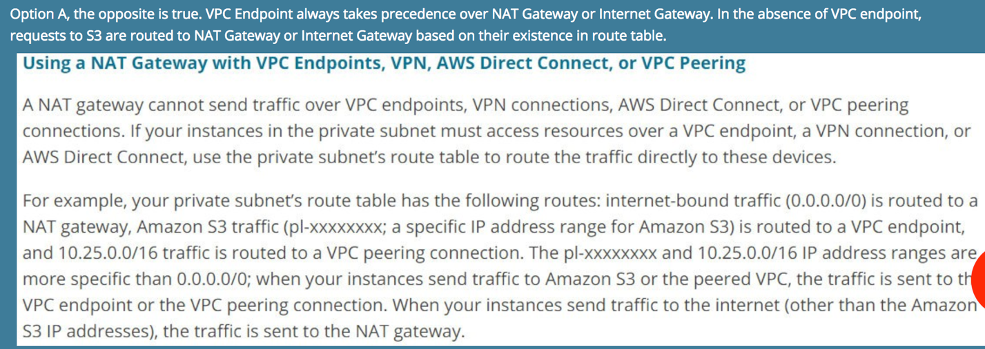

vpc endpoint: cannot cross region, but can support some access policy for the resources

ACL: rules are evaluated from small to high, but once matched, break

In ACL, outbound ip/port means the ip/port of client side, not server side

When SSH, 22 is on server side with inbound, and ephemeral port is on client side for outbound

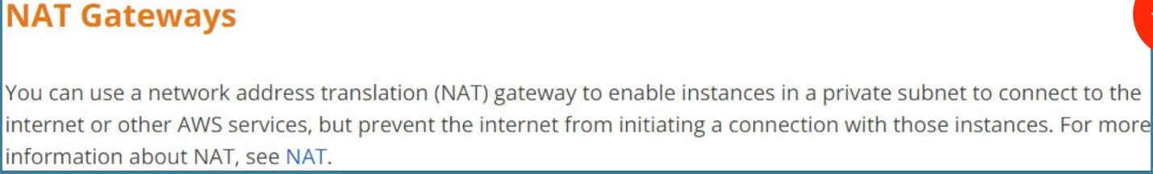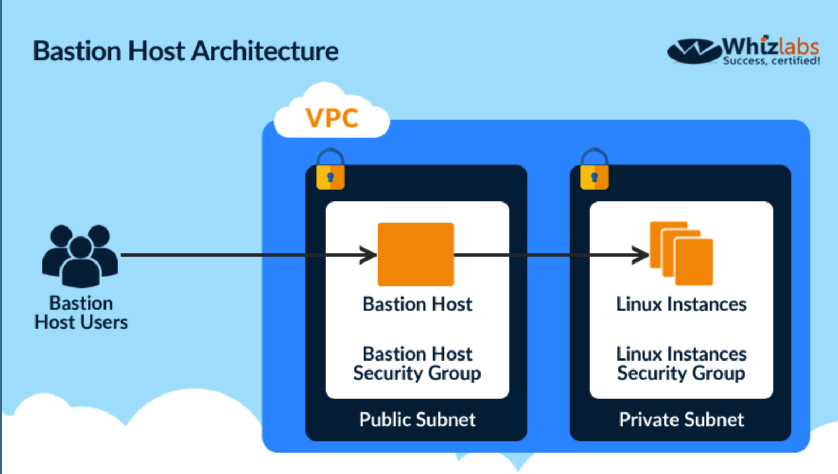

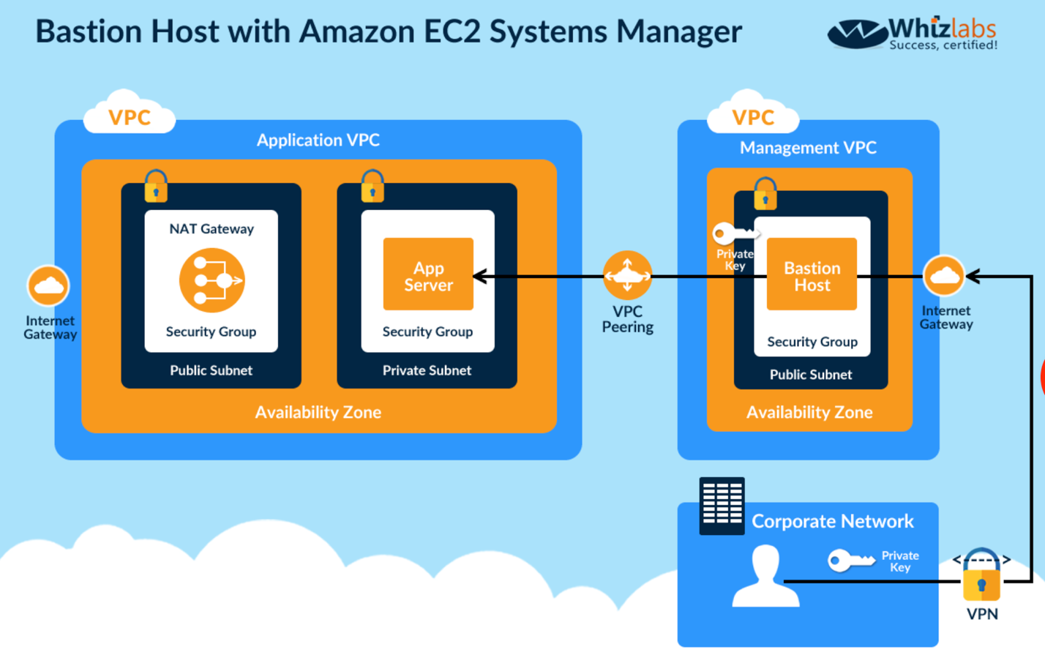

Bastion is for SSH and tcp

When corporate access only, public subnet is not okay. Must use VPN instead.

There are two types of VPC endpoints: *interface endpoints* and *gateway endpoints*. Create the type of VPC endpoint required by the supported service. An [interface endpoint](https://docs.aws.amazon.com/vpc/latest/userguide/vpce-interface.html) is an elastic network interface with a private IP address that serves as an entry point for traffic destined to a supported service. A [gateway endpoint](https://docs.aws.amazon.com/vpc/latest/userguide/vpce-gateway.html) is a gateway that is a target for a specified route in your route table, used for traffic destined to a supported AWS service. The following AWS services are supported:

* Amazon S3
* DynamoDB

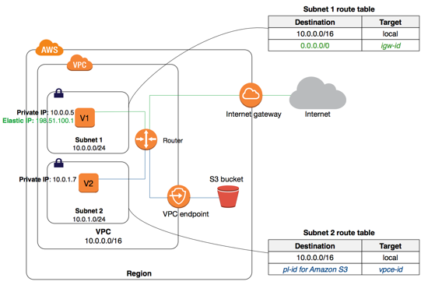

Endpoint connection cannot be used for the traffic outside the vpc

Endpoint connection is only within one region

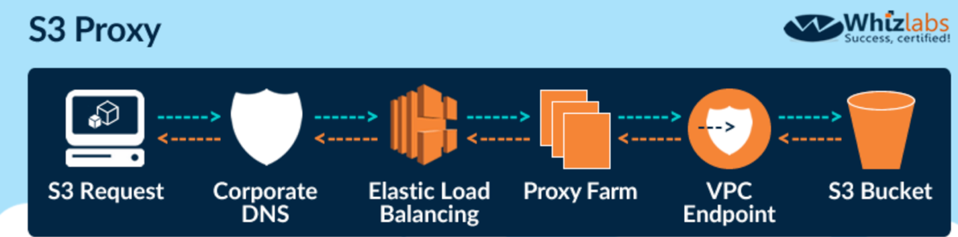

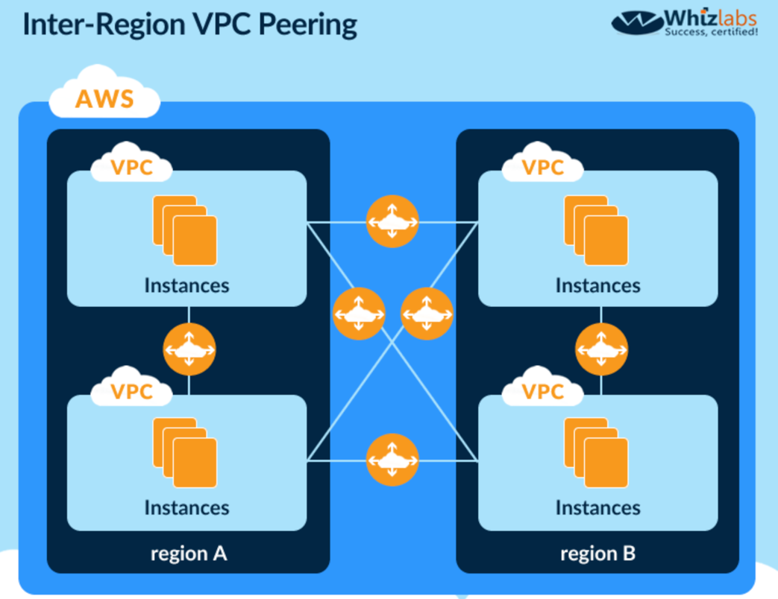

The first four IP addresses and the last IP address in each subnet CIDR block are not available for you to use, and cannot be assigned to an instance.

An Amazon-provided private (internal) DNS hostname resolves to the private IPv4 address of the instance, and takes the form ip-*private-ipv4-address*.ec2.internal for the us-east-1 region, and ip-*private-ipv4-address*.*region*.compute.internal for other regions (where *private-ipv4-address* is the reverse lookup IP address). You can use the private DNS hostname for communication between instances in the same network, but we can't resolve the DNS hostname outside the network that the instance is in.

A public (external) DNS hostname takes the form ec2-*public-ipv4-address*.compute-1.amazonaws.com for the us-east-1 region, and ec2-*public-ipv4-address*.*region*.compute.amazonaws.com for other regions. We resolve a public DNS hostname to the public IPv4 address of the instance outside the network of the instance, and to the private IPv4 address of the instance from within the network of the instance.

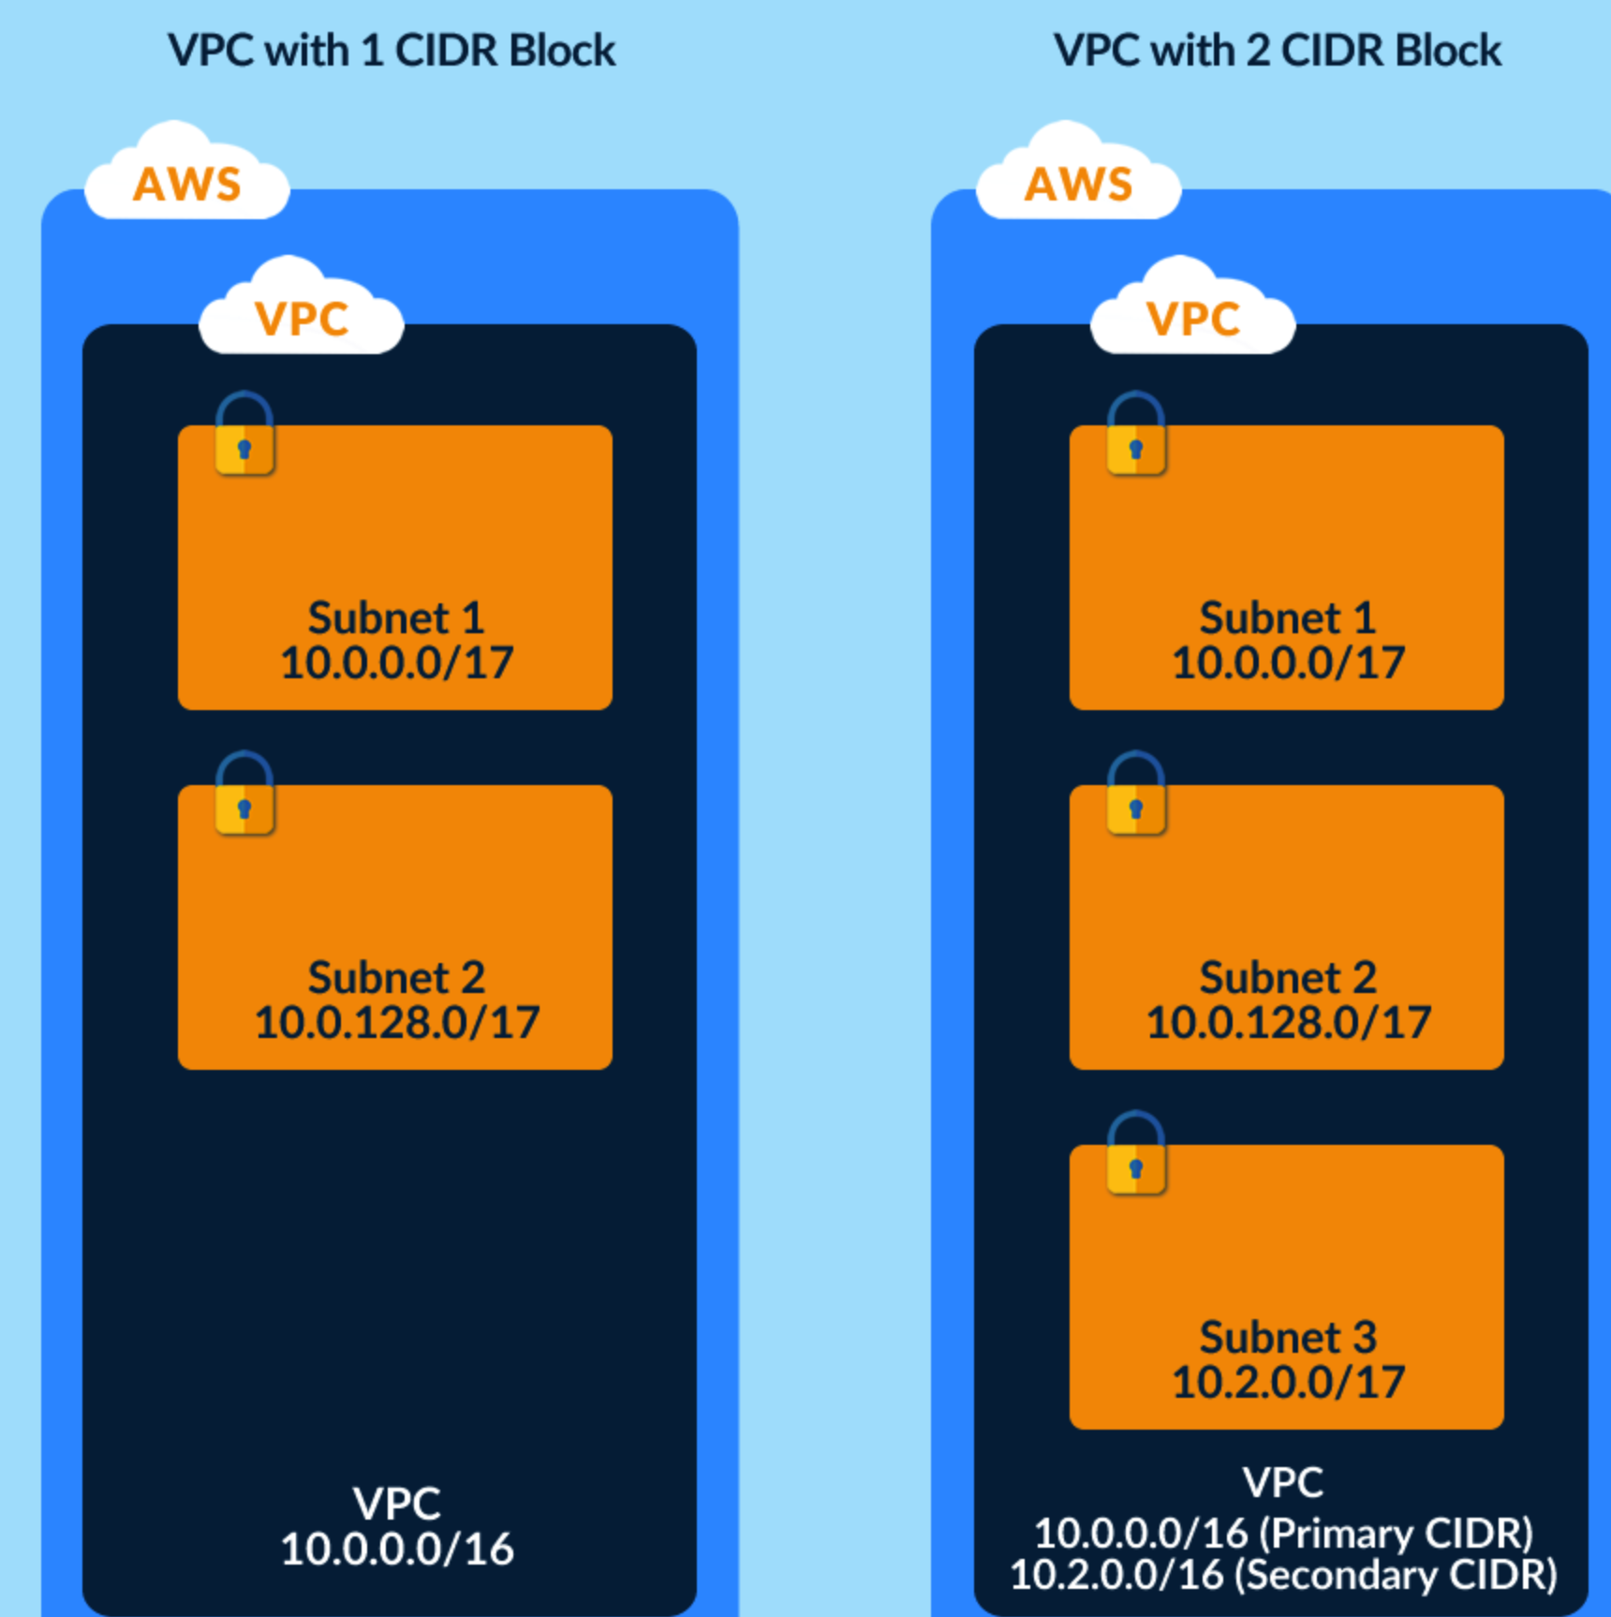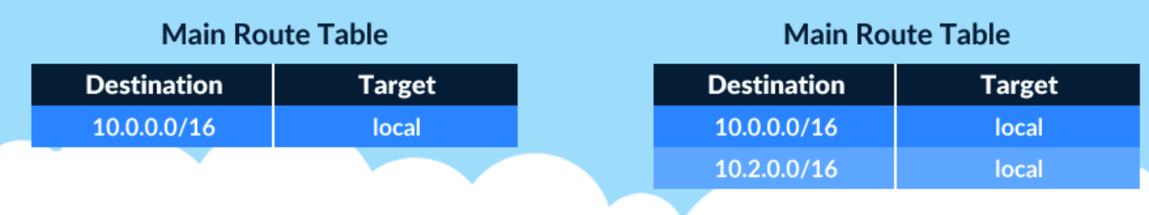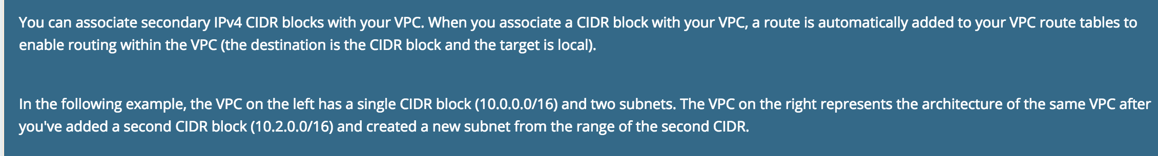

If you create a new subnet in this VPC, it's automatically associated with the main route table, which routes its traffic to the virtual private gateway. I

DynamoDB: there is no multi-AZ concept for this service.

*Amazon DynamoDB global tables* provide a fully managed solution for deploying a multi-region, multi-master database, without having to build and maintain your own replication solution. When you create a global table, you specify the AWS regions where you want the table to be available. DynamoDB performs all of the necessary tasks to create identical tables in these regions, and propagate ongoing data changes to all of them.

Along with specifying configuration settings for your Lambda function, you can also use environment variables to store sensitive information, such as a database password, using [AWS Key Management Service](https://docs.aws.amazon.com/kms/latest/developerguide/) and the Lambda console's encryption helpers.

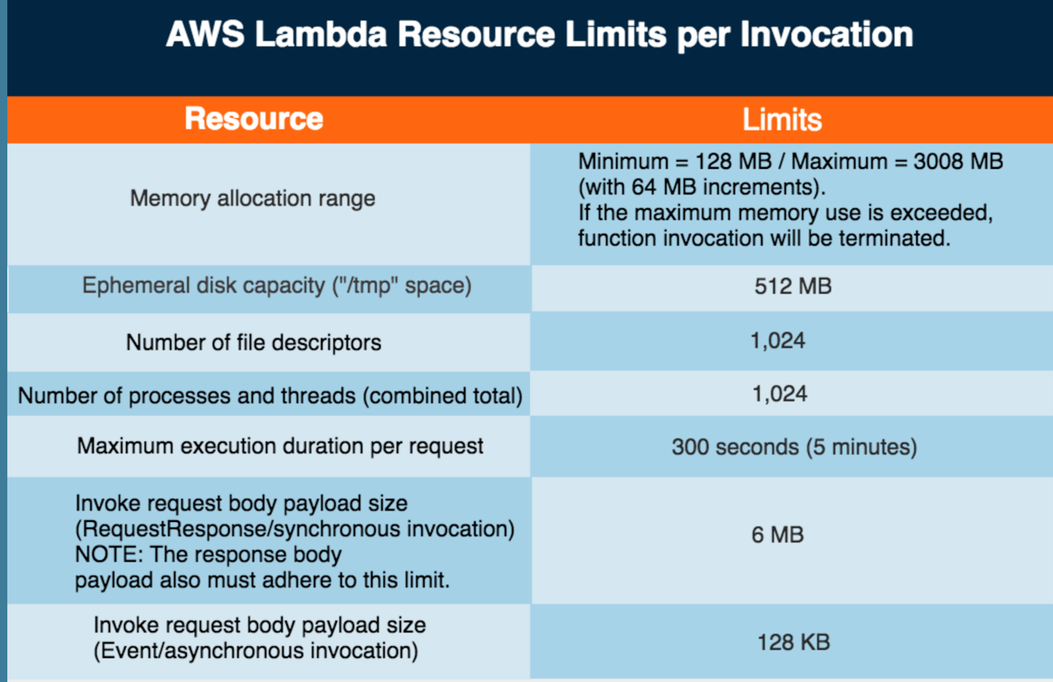

codepipeline and opswork are not event based for lambda

Dead-letter queues are a powerful concept, which help software developers find software issue patterns in their asynchronous processing components. The way it works is simple—when your messaging component receives a message and detects a fatal or unhandled error while processing the message, it sends information about the message that failed to another location, such as another queue or another notification system. [SQS provides dead letter queues](https://docs.aws.amazon.com/AWSSimpleQueueService/latest/SQSDeveloperGuide/sqs-dead-letter-queues.html) today, sending messages that couldn’t be handled to a different queue for further investigation.

AWS Lambda Dead Letter Queues builds upon the concept by enabling Lambda functions to be configured with an SQS queue or SNS topic as a destination to which the Lambda service can send information about an asynchronous request when processing fails. The Lambda service sends information about the failed request when the request will no longer be retried.

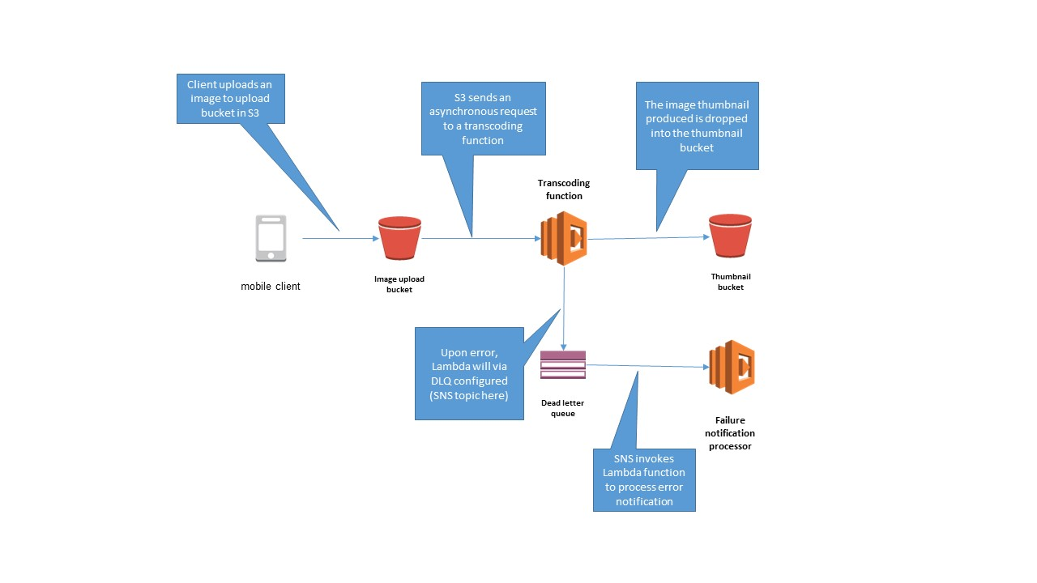

AWS Lambda supports synchronous and asynchronous invocation of a Lambda function. You can control the invocation type only when you invoke a Lambda function (referred to as on-demand invocation). The following examples illustrate on-demand invocations:

* Your custom application invokes a Lambda function.
* You manually invoke a Lambda function (for example, using the AWS CLI) for testing purposes.

In both cases, you invoke your Lambda function using the [Invoke](https://docs.aws.amazon.com/lambda/latest/dg/API_Invoke.html) operation, and you can specify the invocation type as synchronous or asynchronous.

When you use an AWS services as a trigger, the invocation type is predetermined for each service. You have no control over the invocation type that these event sources use when they invoke your Lambda function.

For example, Amazon S3 always invokes a Lambda function asynchronously and Amazon Cognito always invokes a Lambda function synchronously. For poll-based AWS services (Amazon Kinesis, Amazon DynamoDB, Amazon Simple Queue Service), AWS Lambda polls the stream or message queue and invokes your Lambda function synchronously.

IAM role on resource: it is action API level, not control whether or not the caller has access to this resource

Lambda: libraries should come with the code

SQS+Lambda: 10 messages max for a batch

When using an [AWS Cloudwatch](https://aws.amazon.com/cloudwatch/) rule to trigger a Lambda event, one of the multiple options you have to pass data onto your Lamba function is “Constant (JSON Text)”. This handy feature allows you to send static content to your function instead of the matched event.

If you use the RequestResponse (synchronous) invocation option, the function will be invoked only once. If you use the Event (asynchronous) invocation option, the function will be invoked at least once in response to an event and the function must be idempotent to handle this.

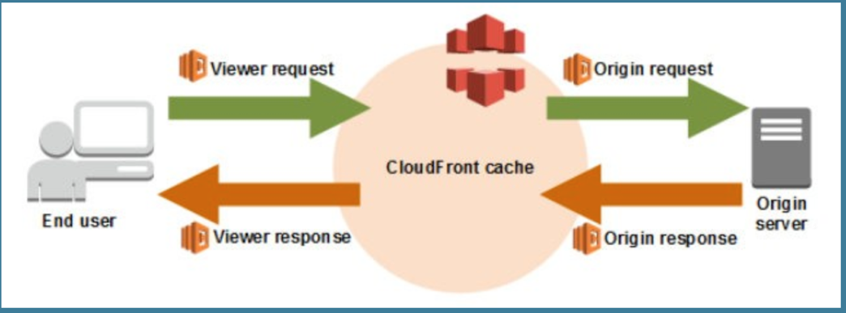

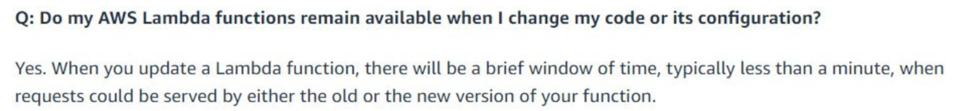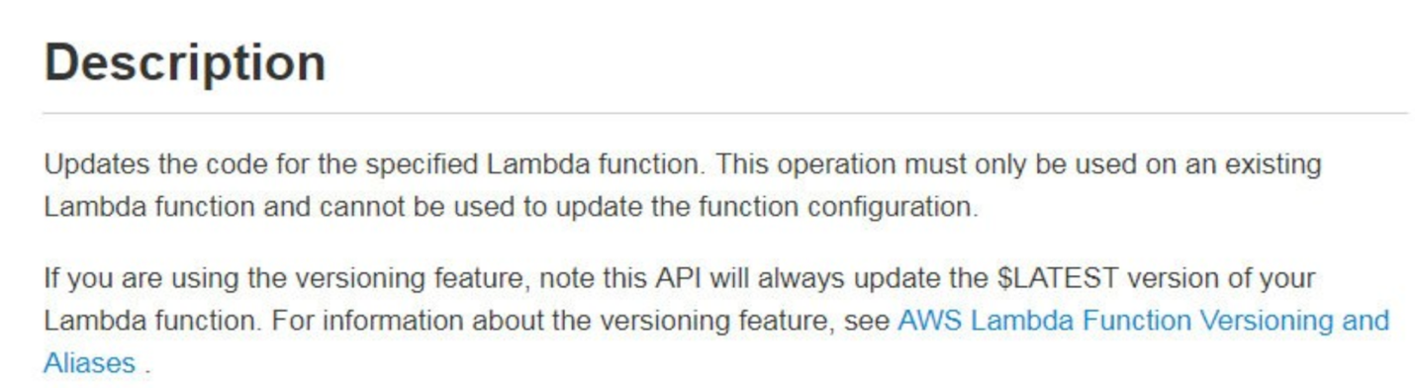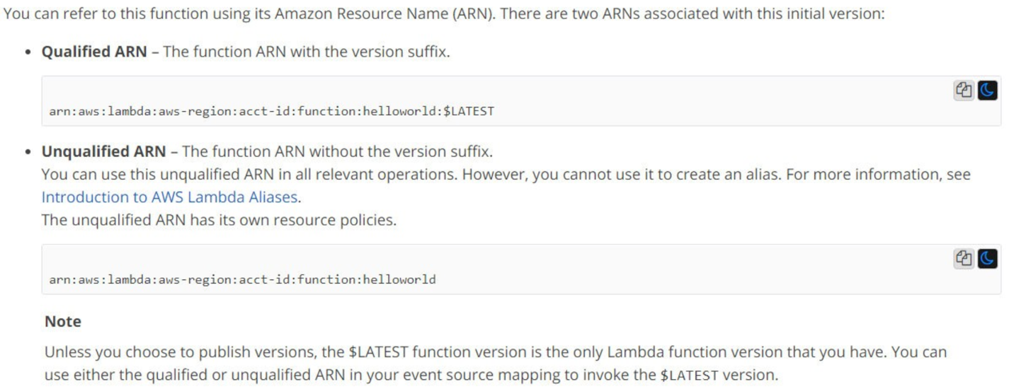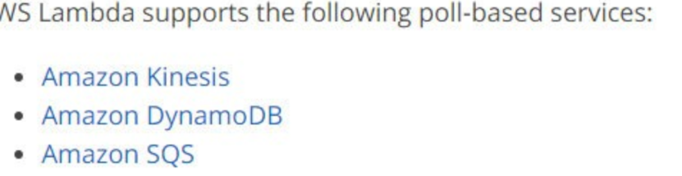

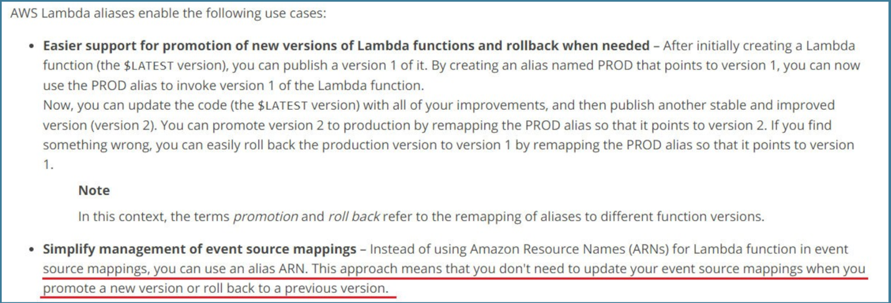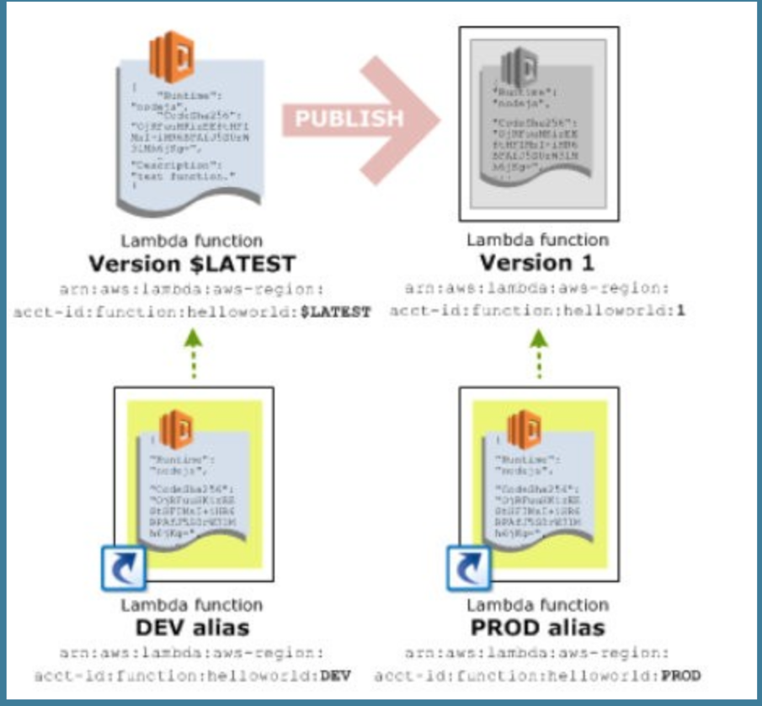

Function policy: for cross account lambda setup, and only CLI

Dead letter queue is not enabled by default. Failed task is discarded.

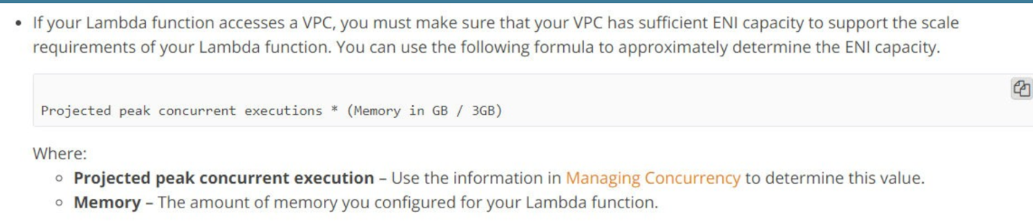

Lambda monitoring metrics: invocation, errors, dead letter error, duration, throttles, concurrent Execution, unreserved concurrent Execution

getFunctionVersion() ==AWS_LAMBDA_FUNCTION_VERSION

If any of these failures occur, your function will throw an exception. How the exception is handled depends upon how the Lambda function was invoked:

* **Event sources that aren't stream-based** – Some of these event sources are set up to invoke a Lambda function synchronously and others invoke it asynchronously. Accordingly, exceptions are handled as follows:

* + **Synchronous invocation** – The invoking application receives a 429 error and is responsible for retries. For a list of supported event sources and the invocation types they use, see [Supported Event Sources](https://docs.aws.amazon.com/lambda/latest/dg/invoking-lambda-function.html). These event sources may have additional retries built into the integration.

If you invoked the Lambda function directly through AWS SDKs, your client receives the error and can choose to retry.

* + **Asynchronous invocation** – Asynchronous events are queued before being used to invoke the Lambda function. If AWS Lambda is unable to fully process the event, it will automatically retry the invocation twice, with delays between retries. If you have specified a Dead Letter Queue for your function, then the failed event is sent to the specified Amazon SQS queue or Amazon SNS topic. If you don't specify a Dead Letter Queue (DLQ), which is not required and is the default setting, then the event will be discarded. For more information, see [Dead Letter Queues](https://docs.aws.amazon.com/lambda/latest/dg/dlq.html).

* **Poll-based (or pull model) event sources that are stream-based**: These consist of Kinesis Data Streams or DynamoDB. When a Lambda function invocation fails, AWS Lambda attempts to process the erring batch of records until the time the data expires, which can be up to seven days.

The exception is treated as blocking, and AWS Lambda will not read any new records from the shard until the failed batch of records either expires or is processed successfully. This ensures that AWS Lambda processes the stream events in order.

* **Poll-based event sources that are not stream-based:** This consists of Amazon Simple Queue Service. If you configure an Amazon SQS queue as an event source, AWS Lambda will poll a batch of records in the queue and invoke your Lambda function. If the invocation fails or times out, every message in the batch will be returned to the queue, and each will be available for processing once the [Visibility Timeout](https://docs.aws.amazon.com/AWSSimpleQueueService/latest/SQSDeveloperGuide/sqs-visibility-timeout.html) period expires. (Visibility timeouts are a period of time during which Amazon Simple Queue Service prevents other consumers from receiving and processing the message).

Once an invocation successfully processes a batch, each message in that batch will be removed from the queue. When a message is not successfully processed, it is either discarded or if you have configured an [Amazon SQS Dead Letter Queue](https://docs.aws.amazon.com/AWSSimpleQueueService/latest/SQSDeveloperGuide/sqs-configure-dead-letter-queue.html), the failure information will be directed there for you to analyze.